CPAce: Adaptive Board Exam Review System with Weakness Detection
and Spaced Repetition

Kristine Panaligan De Torres
Mac Millan Mayuga Abrenica
Axle Iverson Martin Hernando
College of Informatics and Computing Sciences
Batangas State University
The National Engineering University
ARASOF – Nasugbu
2026
CPAce: Adaptive Board Exam Review System with Weakness Detection
and Spaced Repetition

A Capstone Project
presented to
the Faculty Committee of the College of Informatics and Computing Sciences
Batangas State University
The National Engineering University
ARASOF - Nasugbu Campus

In partial fulfillment
of the requirements of the degree
Bachelor of Science in Information Technology
Business Analytics Track

by
Kristine Panaligan De Torres
Mac Millan Mayuga Abrenica
Axle Iverson Martin Hernando
March 2026
TABLE OF CONTENTS
CHAPTER

I. THE PROBLEM AND ITS BACKGROUND

Introduction 1

Background of the Study 6

Objectives of the Study 11

Significance of the Study 13

Scope and Limitation of the Study 15

Definition of Terms 21

II. REVIEW OF LITERATURE AND STUDIES

Conceptual Literature 26

Research Literature 37

Technical Background 60

Theoretical Framework 65

Conceptual Framework 72

Synthesis 79

III. DESIGN AND METHODOLOGY

Research Design 86

Design Stages of the Process 88

Development Process 93

Testing Process 94

Debugging Process 95

Validation Process 96

Programming Procedure 98

Software and Hardware Needed in the Development 116

Software Requirements 116

Hardware Requirements 119

Instrumentation 121

Preparation and Evaluation 133

Ethical Considerations 136

LIST OF TABLES
Table
I. Software Needed in the Development ....................................................... 116
II. Hardware Needed in the Development .................................................... 119
III. Benchmarking Tools and Corresponding Metrics per Evaluation
Area.......................................................................................................... 122
IV. Benchmarking Test Configuration .......................................................... 126
V. System Functionality Evaluation Criteria for CPAce............................... 134

LIST OF FIGURES
Figure
1 Bjork’s Desirable Difficulties Framework (DDF)...................................... 65
2 Cognitive Load Theory .............................................................................. 66
3 Self-Determination Theory (SDT) ............................................................. 66
4 Conceptual Framework of the Study ......................................................... 72
5 Agile Methodology ………………............................................................ 89
6 System Architecture of CPAce .................................................................. 98
7 Requirements Analysis of CPAce ............................................................. 101
8 Use Case Diagram of CPAce.................................................................... 104
9 Context Diagram of CPAce ………………………….............................. 107
10 Diagram 0 of CPAce .............................................................................. 110
11 Conceptual Entity-Relationship Diagram of CPAce ............................. 114

CHAPTER I
THE PROBLEM AND ITS BACKGROUND

INTRODUCTION
The pursuit of professional licensure constitutes one of the most consequential milestones in a graduate's academic and professional trajectory. Unlike routine assessments embedded within formal academic curricula, licensure examinations are high-stakes, nationally standardized evaluations that demand not only broad subject familiarity but an exceptional and sustained depth of mastery across multiple competency domains, assessed under conditions of strict temporal constraint and measured against benchmarks calibrated to reflect professional rather than merely academic competence [1]. For graduates pursuing board examination clearance, the preparation period preceding the examination is as intellectually demanding as the formal years of study that precede it, and yet it is precisely at this stage that the structural deficiencies and methodological inadequacies of conventional review approaches most critically undermine the effectiveness of academic preparation.
Academic preparation for professional licensure has been significantly transformed by the integration of educational technology into high-stakes review contexts. Unlike conventional review tools that present identical material to all users regardless of individual performance histories, intelligent digital review platforms continuously model each learner's knowledge state and dynamically personalize the study experience in real time [2]. A scoping review done by Du Plooy et al. [3] encompasses 69 peer-reviewed studies published from the year 2012 to 2024 revealed consistent evidence that personalized learning environments produce significantly improved academic performance and engagement compared to non-adaptive methods, with the greatest changes noted in examination-focused contexts. These findings establish a strong empirical basis for implementing adaptive learning systems in professional licensure preparation.
Adaptive learning systems draw much of their effectiveness from empirically validated cognitive strategies that address how learners encode, retain, and retrieve information over extended study periods. Based on Ebbinghaus's [4] research on the forgetting curve, one of the most effective strategies involves revisiting studied materials with spaced intervals, scheduled just before the expected time of forgetting- as a result, consuming knowledge more efficiently than the cramming techniques commonly used by most learners [5]. The SM-2 algorithm, created by Piotr Wozniak and used in applications such as Anki and SuperMemo, calculates customized reviews based on each learner's recall quality for specific items, dynamically modifying intervals as performance changes. [6] Jape et al. [7] stated that students using this method showed significantly greater long-term retention than those who use massed practice, while Gilbert et al. [8] found a strong positive correlation between consistent Anki usage and improved academic performance among medical school groups.
Spaced repetition is a learning method based on cognitive science. It involves studying material at moderately longer intervals to help learners remember it for the long term and reduce forgetting. By reviewing information just before learners are likely to forget it, spaced repetition makes study sessions more effective and helps learners retain more. Still, while spaced repetition helps with timing reviews, it only solves part of the problem for board exam candidates. It is just as important for the system to find specific knowledge gaps using real-time competency profiling. Using learning analytics and formative assessments, competency profiling looks at how learners respond to questions and builds updated profiles that show not just how much material has been studied, but also how well each area is understood [9]. Hernandez-Campos, Gonzalez-Torres, and Garcia-Penalvo [10] confirmed through a systematic literature review that timely, competency-specific diagnostic feedback consistently and substantially improves student performance, especially when learners receive clear, data-driven guidance on where to focus their efforts. It is the convergence of adaptive scheduling with real-time competency analysis that defines the most complete evidence-based approach to examination preparation.
In the Philippines, the need for adaptive and diagnostic review support is most sharply felt in the context of the Certified Public Accountant Licensure Examination (CPALE), administered by the Professional Regulation Commission (PRC). The CPALE includes six main subject areas: Financial Accounting and Reporting (FAR), Advanced Financial Accounting and Reporting (AFAR), Management Services (MS), Taxation (TAX), Auditing (AUD), and Regulatory Framework for Business Transactions (RFBT). Candidates have to pass all six subjects in one exam window, so mastering only some subjects is not enough [11]. Because of this, candidates face a lot of pressure to keep their skills strong in every area. It is crucial to spot and address any weaknesses in specific subjects to succeed.
National passing rates reflect the severity of this challenge. Official PRC data show that only 30.28% of examinees passed the May 2024 CPALE and only 30.17% passed the December 2024 administration [12]. These figures point to a systemic gap between how accountancy graduates currently prepare and the standard of mastery the examination demands. Commercial review centers, compiled printed question banks, and subscription-based online quiz platforms share a fundamental limitation: they are non-adaptive. They deliver the same content to every user at the same difficulty level, regardless of individual competency profiles, and they neither identify persistent subject weaknesses nor schedule review at intervals optimized to prevent forgetting. As a result, students are left to self-diagnose their own gaps — a task that cognitive research has consistently shown to be unreliable, as learners routinely overestimate mastery of familiar material while underestimating genuine deficiencies [13].
At Batangas State University ARASOF-Nasugbu, a campus of Batangas State University, the National Engineering University (TNEU), known for its strong focus on academic excellence, research, and community service, the lack of adaptive review support is especially noticeable. The Bachelor of Science in Accountancy (BSA) program prepares graduates who aim to pass the CPALE, but there is no campus-based digital system to help them study in a personalized or data-driven way. BSA students mostly use printed review materials, commercial quiz platforms, and practice exams given by faculty. While these resources are helpful on their own, together they do not offer the adaptive intelligence, scheduling features, or diagnostic accuracy needed to fully prepare students for the CPALE.
A preliminary needs assessment among the campus's BSA students showed that many respondents could not accurately identify their weak areas in CPALE subjects. Most relied on non-adaptive review resources and clearly needed a structured, data-driven platform that offers personalized feedback and guided study schedules. These results match broader evidence from both global and national studies, and they directly support creating an intelligent review system designed for CPALE candidates at BatStateU TNEU ARASOF-Nasugbu.
To address this critical gap, the researchers will develop CPAce, an Adaptive Board Exam Review System with Weakness Detection and Spaced Repetition. CPAce is a mobile-friendly, web-based review platform made for BSA students at Batangas State University TNEU ARASOF-Nasugbu. It aims to replace passive, one-size-fits-all review methods with a more dynamic, evidence-based, and personalized approach. CPAce uses three main features. The Weakness Detection Module keeps track of each student's skills in all six CPALE subjects and updates them after every practice session. The Spaced Repetition Review Scheduler uses the SM-2 algorithm to bring back review items at intervals that fit each student's recall accuracy, helping them remember information longer. The Adaptive Quiz Engine creates practice questions on the spot, adjusting the difficulty to match each student's current weaknesses and review schedule. This helps students focus on the areas where they need the most improvement.

BACKGROUND OF THE STUDY
The existing process of CPALE preparation at Batangas State University TNEU ARASOF-Nasugbu is carried out through a combination of individual self-study, faculty-administered practice examinations, and commercially available review materials. Students typically begin their board review several months before the scheduled examination date, working through printed question banks and online quiz platforms that present a fixed and uniform set of practice items to every user regardless of individual performance or readiness. There is no campus-based system that records individual student performance over time, identifies persistent knowledge gaps across the six CPALE subject domains, or adjusts the study experience to reflect each student's unique competency profile. Preparation is entirely self-directed, and the quality of that preparation depends almost entirely on each student's own capacity to assess their readiness, recognize their weaknesses, and allocate their limited study time accordingly.
In the current CPALE preparation process, several recurring problems have been observed that significantly impede effective review among BSA students at the campus. Students frequently struggle to accurately assess their own level of mastery across different subject areas, often continuing to review topics they already understand reasonably well while unknowingly neglecting areas where deeper remediation is urgently needed. This pattern reflects the well-documented phenomenon of illusion of competence in self-regulated learning, wherein prior exposure to a topic creates a false sense of familiarity that is mistaken for actual mastery [13].
Another critical problem is the natural decay of memory over extended preparation periods. Content studied weeks or months earlier is often substantially forgotten by the time the examination date approaches, as a direct consequence of the forgetting curve operating in the absence of structured, spaced reinforcement [4]. Without a mechanism to detect and correct this drift, students arrive at the examination having invested considerable time in review but retaining far less than they believe. Faculty members, meanwhile, face difficulty in monitoring preparation quality in the absence of centralized performance data, often becoming aware of a student's serious preparation gaps only after a failed board attempt, at which point timely intervention is no longer possible.
A similar concern exists at the broader institutional and national level. The Certified Public Accountant Licensure Examination, governed by Republic Act No. 9298 or the Philippine Accountancy Act of 2004 and administered by the Professional Regulation Commission, is the sole licensure gateway for BSA graduates [11]. The exam now covers six subject areas, following changes made by PRBOA Resolution No. 30, Series of 2022. Examinees must pass all subjects at once to succeed [14]. Despite these changes, national passing rates are still low. In December 2024, only 30.17% of examinees passed [12]. Students at regional campuses like BatStateU TNEU ARASOF-Nasugbu face even more difficulties because they have less access to top review programs and strong institutional support [11]. Some universities are starting to use technology to help students prepare, but there is still a clear need for campus-based, adaptive review tools designed specifically for the CPALE.
At the institutional level, a similar trend can be observed in the CPALE performance of graduates from Batangas State University TNEU ARASOF–Nasugbu. Based on official records obtained from the Professional Regulation Commission (PRC) from 2010 to 2025 [15] compiled by the researchers, the campus recorded a total of 192 examinees, with 104 passers, resulting in an overall passing rate of 54.17%, while the average of the passing rates across the individual examination cycles was approximately 43.42%. Despite this relatively favorable rate compared to recent national averages, the data reveal inconsistent performance across examination periods. There were instances of strong results, but these were followed by notable declines, including examination cycles with very low or no passing outcomes. This pattern suggests that student performance is not consistently sustained over time, indicating possible gaps in the review and preparation process.
These findings imply that while students possess the necessary academic foundation, the absence of a structured and data-driven review approach may limit their ability to consistently identify weaknesses and maintain mastery across all subject areas. This institutional evidence further supports the need for a more systematic and adaptive review mechanism to improve CPALE outcomes.
To address these challenges, the researchers developed CPAce, an adaptive CPALE review system that uses weakness detection and spaced repetition. CPAce aims to make CPALE preparation more active, personalized, and data-driven. The system uses the SM-2 spaced repetition algorithm to schedule review items at the right times, helping students remember concepts just before they might forget them. This approach helps fight the forgetting curve and supports long-term retention [16], [4]. CPAce also tracks each student's performance across all six CPALE subject areas, finds knowledge gaps, and adjusts the content so students spend their study time where it will help them most [3], [17], [18].
Beyond its adaptive core, CPAce uses gamification features like points, badges, streaks, and progress tracking to keep students engaged and motivated during the long preparation period [19], [20], [21]. These tools are not just for show; research supports their role in helping students stay motivated and rewarding steady effort, especially when motivation can drop and affect preparation quality [15], [22]. CPAce also offers a learning analytics dashboard that gives faculty and the Program Chair real-time, subject-level insights into how cohorts are performing. This helps them spot students who may be struggling early on and provide targeted support before a failed exam attempt makes it harder to help [23], [24].
Through the personalization and intelligent automation of CPALE review, CPAce addresses the structural deficiencies of existing preparation tools while aligning with the university's commitment to academic excellence and student success. Its implementation is intended to benefit not only the current cohort of BSA students at BatStateU TNEU ARASOF-Nasugbu but also to serve as a replicable model for other campuses seeking to improve licensure examination outcomes through evidence-based, technology-driven review support. Above all, CPAce upholds the academic investment of every student working toward the CPA credential, ensuring that their preparation is supported by a system designed from the ground up to give them every reasonable advantage in one of the most consequential examinations of their professional lives.

OBJECTIVES OF THE STUDY
The main objective of the study is to develop an Adaptive Board Exam Review System with Weakness Detection and Spaced Repetition for Accountancy students of Batangas State University TNEU ARASOF–Nasugbu Campus. This system is a mobile-friendly, web-based platform that aims to provide personalized and intelligent review sessions tailored for the Certified Public Accountant Licensure Examination (CPALE).
Specifically, the study aims to:
- Identify the features to be incorporated in the system to effectively address the challenges encountered by Accountancy students in preparing for the CPALE.
- Evaluate the functionality of the developed system in terms of:
  - Accuracy of the Weakness Detection Module in identifying weak CPALE subject area performance using Precision, Recall, and F1-Score; and
  - Correctness of the Spaced Repetition Scheduler in computing review intervals according to the SM-2 algorithm.
- Measure the performance efficiency of the developed system using benchmarking tools, specifically in terms of:
3.1. Response Time;
3.2. Throughput;
3.3. Scalability; and
3.4. Reliability under load.

SIGNIFICANCE OF THE STUDY
The implementation of “CPAce: An Adaptive CPA Board Exam Review System with Weakness Detection and Spaced Repetition” is a technology-based review platform designed to improve board exam preparation through personalized learning. The project is expected to benefit various stakeholders, including the institution, colleges, students, faculty members, the Program Chair, and future researchers.
Batangas State University TNEU ARASOF-Nasugbu. The system will help the university improve its CPA board examination performance by supporting students with a guided and monitored review platform. Since board passing rates affect the school’s reputation, accreditation, and enrollment, CPAce could help boost the university’s overall standing. Through improved student preparedness, the university can further demonstrate its commitment to producing competent and board-ready graduates.
College of Accountancy, Business Economics, and International Hospitality Management. CPAce will help the college to monitor student performance across major accounting subjects. By reviewing combined data and performance reports, the college can identify common challenges and plan targeted review sessions or academic support. These findings will help improve the curriculum and ensure it aligns with the CPA board exam standards. Using these insights, the college can keep improving its review strategies and give graduating students better support.
Accountancy Students. Students will directly benefit from CPAce because it will help them manage the extensive coverage of the CPA board examination. The system will identify their weak topics and will provide repeated exposure to those areas through spaced repetition. This approach will strengthen long-term retention and understanding of key accounting concepts. By tracking their progress, students can make better use of their study time and feel more confident when answering board-type questions. Having an organized review process also lowers uncertainty and helps students prepare for exams in a more focused and strategic way.
Faculty Members. Faculty members will benefit from access to organized student performance data. The system will allow them to see trends in strengths and weaknesses, which will guide their review sessions and teaching strategies. With clearer insights into student learning gaps, instructors will be able to emphasize critical topics and provide targeted academic support. This will improve the overall effectiveness of the review program and strengthen collaboration between faculty and students.
Program Chair. The Program Chair will benefit from the curriculum management tools of CPAce, which include curriculum versioning, Table of Specifications import, and test bank gap detection. The program-level analytics and the review of mock examinations and AI-generated questions also give the Program Chair a clearer view of how well the program prepares students for the CPALE and where faculty support is needed.
Future Researchers. This study will serve as a reference for researchers who will develop similar adaptive learning systems in other academic disciplines. This work will help advance educational technology by showing how weakness detection and spaced repetition can support people preparing for professional board exams. Future researchers could build on this system, add new features, or compare its performance with other methods.
This study is significant as it fills an existing gap in individualized board exam preparation and provides a systematic, data-driven methodology that could enhance learning outcomes, institutional performance, and future research advancement.
SCOPE AND LIMITATION OF THE STUDY
The CPAce is a mobile-friendly, web-based platform developed to support Accountancy students of Batangas State University TNEU ARASOF-Nasugbu in their preparation for the CPALE. The system focuses on delivering a personalized review experience by automatically adjusting to the strengths and weaknesses of each individual user. It covers all subjects under the CPALE curriculum, namely Financial Accounting and Reporting, Advanced Financial Accounting and Reporting, Management Services, Auditing and Assurance, Taxation, and Regulatory Framework for Business Transactions.
At the core of CPAce is a weakness detection feature that tracks how each student performs across different topics and subject areas. Every time a student completes a practice session or mock examination, the system records which items were answered incorrectly and identifies patterns of difficulty over time. Specifically, topics with accuracy below 60% across at least five quiz attempts, or three consecutive incorrect responses within a topic, are classified as weak areas requiring prioritized review. This data is then used to prioritize those weak areas in future review sessions, making sure that the student spends more time on the subjects and concepts that need the most improvement.
To further strengthen retention, CPAce uses spaced repetition to schedule review content. This technique is based on the principle that people remember information better when they review it over longer and longer gaps, instead of cramming. The system figures out the best time to review a topic again by looking at how well the student did before. This helps make sure important ideas are not forgotten before the exam.
Beyond its adaptive core, CPAce also includes several supporting features that enhance the overall review experience. The CPALE Mock Examination Simulator recreates full-length, timed exam conditions similar to the actual board examination, with results automatically integrated into each student’s competency profile. The system also provides a Performance Dashboard and Progress Reports, allowing students to monitor their subject mastery, identify areas for improvement, track spaced repetition progress, and estimate their exam readiness. For faculty and coordinators, a Question Bank Management module is available to upload, organize, and categorize questions by subject and difficulty. In addition, secure role-based authentication is implemented to ensure the protection of academic data and user access.
CPAce further includes Training and Testing Mode features, providing students with two distinct operational modes during their review. The Training Mode allows students to study and practice without time pressure, with immediate feedback provided after each item to support active learning. The Testing Mode simulates actual examination conditions, including strict time limits and deferred feedback, to build examination endurance and familiarity with high-stakes testing environments. In addition, CPAce includes a Review Notification feature that sends timely reminders to students when scheduled review sessions are due based on their spaced repetition intervals, ensuring that review activities are completed at the optimal time for retention. The system also identifies and displays the specific number of days remaining until the next scheduled review for each topic, giving students a clear and structured timeline of their upcoming study activities and enabling better personal planning in the lead-up to the board examination.
CPAce gives students access to different types of learning activities, including topic-specific practice drills, full-length mock board examinations, and automatically generated review queues based on their spaced repetition schedule. A personal performance dashboard is also available, showing each student's progress per subject, a summary of persistent weak areas, overall readiness level, and a record of completed review sessions. These features are intended to help students plan their study habits more effectively and stay aware of where they stand in their preparation.
CPAce also includes AI-assisted features. An AI Tutor gives students chat-based study assistance while they review. Faculty can use AI to draft or paraphrase questions, and the system can generate substitute questions when a replacement item is needed. All AI-generated substitute questions are reviewed by the faculty or the Program Chair before they are published to students.
For class quizzes and mock examinations, CPAce provides browser-based proctoring. During a session the system captures webcam images and logs tab-switch and window focus events. These records are summarized in a risk-score breakdown, and faculty can watch ongoing sessions through live monitoring. Captured images are automatically deleted once the retention period has passed.
CPAce also has a Curriculum Management module. It supports curriculum versioning, the import of the PRC Table of Specifications (TOS), and an audit trail of curriculum changes. The system checks the test bank against the curriculum and reports topics with too few questions, and questions can be copied from one curriculum version to another.
For academic administration, CPAce lets the Program Chair manage sections and year levels and assign faculty to subjects and sections. Student records can be imported and exported in bulk through CSV files, accounts are set up through one-time password (OTP) verification, and graduating students can be moved to alumni status.
CPAce also includes communication modules. Users can send direct and group messages, announcements and communications can be sent to users, and the Community Hub allows posts and shared resources. A global search helps users find content across the system.
The system is designed for four main groups of users. Accountancy students serve as the primary users, interacting with the platform daily to complete reviews and track their exam readiness. College of Accountancy, Business, Economics, and International Hospitality Management faculty in the Bachelor of Science in Accountancy program can review class performance data to spot common student weaknesses and plan extra lessons as needed. The Program Chair oversees the curriculum, the coverage of the test bank, program-level analytics, and the setup of sections and student accounts. BatStateU BSA alumni take part in the Community Hub and can guide current students. Batangas State University can also use this system to help improve its CPALE passing rates.
CPAce is developed as a web-based platform built with PHP and MySQL for the backend, using the Laravel 12 framework and Composer, and HTML, CSS, JavaScript, and Bootstrap 5 for the frontend. A REST API layer with token-based authentication serves the mobile client, so students can use the system on both web and mobile. The team follows an Agile approach, releasing updates in stages, making improvements based on testing and feedback, and continuing to enhance the platform as development goes on.
System evaluation is conducted through two complementary approaches: technical benchmarking and functional validation. Technical benchmarking employs Apache JMeter to measure performance metrics including response time, throughput, scalability, and reliability under load. Functional validation is accomplished through User Acceptance Testing (UAT) wherein selected Accountancy students and BSA faculty evaluators execute predefined test cases to verify that all system features operate according to specifications. This study does not employ surveys, questionnaires, or opinion-based instruments; all evaluation is based on objective performance metrics and functional test case results.
There are, however, boundaries to what CPAce is designed to do. The system is built specifically for Accountancy students of BatStateU TNEU ARASOF-Nasugbu and is not intended to be deployed for other degree programs or institutions at this point in time. The question bank is also tied to the current CPALE syllabus and will be updated whenever the Professional Regulation Commission changes the exam coverage, subject weightings, or related laws and standards. In addition to its adaptive review and spaced repetition, CPAce uses gamification features like achievement badges and performance streaks to help motivate regular study and keep learners engaged. These features support, but do not replace, the main goal of preparing users for competency-based exams.
The computational accuracy of the weakness detection and spaced repetition features depends on how often students use the platform. If students log in only occasionally or do not complete review sessions, the system will not have enough data to make helpful personalized adjustments. Since CPAce is web-based, users also need a reliable internet connection to access their review sessions, performance data, and scheduled activities without interruption.
The AI-assisted features also have limits. Content generated by AI, including drafted and substitute questions, is treated only as a draft and must be reviewed by the faculty or the Program Chair before it is used. The accuracy of the AI Tutor’s responses is not guaranteed, so students should use it as a study aid and check important answers against their review materials or with their faculty. Additionally, proctoring requires a device with a working camera, and the user must allow camera access in the browser. It is not a replacement for physical invigilation.
CPAce is designed to complement, rather than replace, established methods of board examination preparation, including formal coaching, review center classes, and academic instruction, thereby providing additional support to the existing educational framework. The platform does not include oral assessments, group discussions, or practical problem-solving activities, which are common in comprehensive review programs. This study evaluates the technical performance and functional correctness of CPAce; validation of its effectiveness on actual learning outcomes and examination performance is beyond the scope of this study and is recommended for future research. Despite these limitations, CPAce aims to fill a clear gap in accessible and intelligent review tools for CPALE candidates, offering students a structured, data-driven way to study independently and track their progress toward passing the board examination.

DEFINITION OF TERMS
To avoid ambiguity, here are the following terms used in this paper:
Adaptive Practice Mode. This term refers to a feature in CPAce that dynamically adjusts the difficulty of practice questions based on ongoing performance, ensuring a personalized review experience.
AI Tutor. This term refers to the chat-based feature in CPAce that gives students study assistance and explanations on CPALE topics through an external AI service.
Algorithm. This term refers to the set of computational rules and instructions embedded in CPAce that govern question selection, difficulty calibration, and performance scoring.
Application Programming Interface (API). This term refers to the defined protocols and tools that enables CPAce to communicate with external services and databases to exchange and process data in a standardized manner.
Assessment. This term refers to the quizzes, mock board examinations, and topic-based tests in CPAce that systematically evaluate a reviewee knowledge and readiness for the CPA Licensure Examination.
CPALE. This term refers to the Certified Public Accountancy Licensure Examination administered by the Professional Regulation Commission of the Philippines that accounting graduates must pass to earn the title of Certified Public Accountant.
CPAce. This term refers to the mobile and web-based CPA review and practice system developed by the researchers, designed to help accounting students prepare for the CPA Licensure Examination through structured practice, mock exams, and performance tracking.
Competency-Based Assessment. This term refers to the evaluation framework in CPAce that measures a reviewee demonstrated mastery of accounting competencies aligned with the standards prescribed by the Professional Regulation Commission.
Curriculum Version and Table of Specifications (TOS). This term refers to a saved version of the CPALE subject and topic structure in CPAce, based on the Table of Specifications (TOS) of the Professional Regulation Commission, which is used to organize the question bank and check its coverage.
Data Analytics. This term refers to the systematic computational analysis of a user accumulated performance data within CPAce, used to identify knowledge gaps and recommend targeted subject areas for further study.
Ease Factor (EF). This term refers to the value in the SM-2 algorithm that determines how fast the review interval of an item grows. It starts at 2.5, is updated after each review based on the recall quality score, and does not go below 1.3.
Formative Assessment. This term refers to the ongoing, low-stakes evaluations within CPAce such as topic quizzes and drills that provide continuous feedback to reviewees throughout the review process.
Gamification. This term refers to the integration of game-design elements in CPAce, including points, achievement badges, and leaderboards, intended to enhance user motivation and consistency in reviewing.
Leaderboard. This term refers to the competitive ranking feature in CPAce that ranks users by their number of correct answers within a weekly, monthly, or all-time period, with other students shown anonymously, to encourage academic motivation among reviewees.
Metadata. This term refers to the structured descriptive data attached to each question in CPAce including subject classification, topic tag, difficulty level, and source reference to enable efficient retrieval and filtering.
Mock Board Examination. This term refers to the full-length, timed simulated examination in CPAce that mirrors the format, coverage, and time constraints of the actual CPA Licensure Examination to benchmark preparedness.
Online Proctoring. This term refers to the browser-based monitoring in CPAce during quizzes and mock examinations, which includes webcam image capture and the logging of tab-switch and window focus events.
Performance Dashboard. This term refers to the centralized visual interface in CPAce that displays a user review progress, assessment scores, accuracy rates, and recommended areas for improvement.
Performance Metrics. This term refers to the quantifiable indicators tracked by CPAce such as accuracy rate, average score per subject, and response time used to objectively measure a reviewee progress over time.
Practice Room. This term refers to the section of CPAce where students practice answering questions.
Proficiency Level. This term refers to the tiered classification in CPAce that groups a reviewee’s mastery into levels based on cumulative assessment performance and achievements in the system.
Program Chair. This term refers to the faculty member who heads the Bachelor of Science in Accountancy program and uses CPAce to manage curriculum versions, review AI-generated questions, and view program-level analytics.
Question Bank. This term refers to the comprehensive repository of examination questions in CPAce classified by subject area, topic, and difficulty level from which all assessments and practice sets are generated.
Recall Quality Score (q). This term refers to the rating from 0 to 5 that shows how well a student recalled an item during review. The SM-2 algorithm uses it to update the Ease Factor and the next review interval.
Review Notes. This term refers to the personal notes that a student writes and keeps in CPAce while reviewing.
Reviewee. This term refers to the primary end-user of CPAce, a student who is taking Bachelor of Science in Accountancy and is actively utilizing the platform to prepare for the Philippine CPA Licensure Examination.
Rival Tier. This term refers to the tier in the competitive ranking of CPAce that groups students who compete against one another.
Single Sign-On (SSO). This term refers to the sign-in method that lets users log in to CPAce with their existing Google instead of a separate password.
Spaced Repetition. This term refers to the cognitive science-based learning technique in CPAce that re-presents previously reviewed questions at increasing intervals to reinforce long-term retention of accounting knowledge.
Topic-Based Practice. This term refers to the targeted practice sets in CPAce that limit questions to a specific subject or subtopic, enabling reviewees to systematically address identified areas of weakness.
Web-Based Platform. This term refers to the type of online system CPAce belongs to, accessible through any web browser without software installation, enabling users to access all review materials from any internet-connected device.

CHAPTER II
REVIEW OF RELATED LITERATURE AND STUDIES
This chapter provides a full overview of the relevant concept and related literature that contribute to the current study's development. The structure consists of six parts: conceptual literature, relevant research from both local and foreign sources, technological background, theoretical framework, conceptual framework, and synthesis.

CONCEPTUAL LITERATURE
Adaptive learning is a method of learning that uses technology to personalize the instructional experience for each student's individual performance, pace of learning, and learning objectives [3]. Du Plooy et al. defined personalized adaptive learning in higher education as a method that uses technology to customize learning experiences of students. Their scope review of 69 studies found that pre-knowledge quizzes were the key catalyst for prompting adaptive content delivery, showing how ongoing performance data supports personalized instruction in a digital learning context [3]. far from traditional classroom instruction, which provides standardized content to all students at a fixed pace regardless of their unique backgrounds and capabilities, an adaptive learning system can dynamically adjust to each learner's strengths and weaknesses, consistently adjusting difficulty levels, order of content, and frequency of review to maintain instruction that is appropriately challenging and relevant [3]
Abeysekera, who studied the perception of online learning among accounting students in the Philippines, stated that a technology-mediated learning environment must consider the learner's cognitive load, highlighting that the quality of digital content and platform design significantly impacts the students' ability to consume and retain academic materials [25]. This discovery emphasizes the importance of creating adaptive systems that can do more than just change information randomly, but also respond to how learners receive and retain knowledge [25]. The core idea of adaptive learning is that, due to each learner's individuality, a system that consistently changes based on individual performance data produces more effective and equitable learning results than one that treats all students as identical [3].
Spaced Repetition is a cognitively based learning strategy that greatly increases long-term knowledge retention by organizing study sessions over gradually increasing time intervals, instead of studying everything in a single session of mass practice [17]. Fallah et al. performed a randomized-controlled study among nurse anesthesia students and discovered that the students who followed a spaced learning schedule demonstrated significantly better results in terms of retention and learning outcomes than those who studied without the help of spaced intervals, confirming that spaced repetition produces long-term memory gains that are both sustainable and measurable even in highly technical and professional fields [26].
The process behind spaced repetition is based on spacing effect, in which suggests that retrieving information from memory becomes more challenging while also becoming more consolidating after a delay, and that each successful retrieval at an increasing interval strengthens the memory trace and extends the period of forgetting [17]. A meta-analysis and systematic review published in the Journal of Medical Internet Research by Martinengo et al. showed that spaced digital education highly promotes learning and long-term retention among technical professionals, with effects consistently favor spaced repetition over massed practice across a wide range of subject domains and setting. [17]. Spaced repetition provides a especially useful and research-validated method for managing cognitive load while maintaining long-term retention for accountancy students preparing for the CPALE, where volume of required knowledge spans up to six advanced subject areas that must be retained over an extended period [26], [17]. The SM-2 (SuperMemo 2) algorithm, created by Piotr Wozniak, is a frequently used method for implementing spaced repetition in digital systems. The SM-2 algorithm generates personalized review intervals for each item based on the learner's self-rated recall performance, dynamically adjusting the ease factor and inter-repetition interval to ensure that well-retained material is reviewed less frequently and items with lower recall scores are revisited earlier [16]. CPAce integrates the SM-2 algorithm as its primary spaced repetition scheduling system, ensuring that each student's review sessions are timed to maximize long-term retention across all six CPALE subject domains.
Weakness Detection in educational technology is a data-driven and systematic process of identifying specific subject areas where a learner performs below a standard level of competency consistently, and based on performance data gathered through ongoing formative assessment conducted throughout the learning process [27]. Parmigiani et al. defined formative assessment as an ongoing assessment that generates information that can be used to adapt instruction and learning in real time to meet each student's individual needs, highlighting that formative data lies not in learners' rankings but in its ability to produce timely feedback that guides future instructions [27].
In digital learning environments, weakness detection is integrated using algorithms that monitor learner response accuracy across topics, automatically flagging areas where students' performance falls below standards and triggering targeted content delivery to address identified gaps without the help of manual intervention from instructors [27]. A study by Ong and Despi from Accountancy, Business, and Management students in the Philippines found that individual differences in how students approach learning tasks significantly influenced academic gaps in specialized subjects, highlighting the importance of identifying and responding to weak areas in specific subjects early in the learning process instead of waiting for the high-level examination to reveal them [28]. The ability to detect and respond to individual weaknesses in real-time is important to any adaptive review system, as it allows the system to continuously prioritize the areas that require attention and ensure that learners focus their limited study time on the content that will have a significant impact on their overall examination readiness [27], [28]. In CPAce, this is accomplished through a unique Weakness Detection Algorithm that analyzes each student's error rates, response accuracy, and consecutive incorrect answers across question categories to build a constantly updated performance profile. Topics that will fall below a certain accuracy are automatically flagged as weak areas and prioritized in the following review sessions, directing the student's study effort to the specific skill gaps most likely to affect their CPALE performance [24].
The Certified Public Accountant Licensure Examination (CPALE) is the official route for emerging Certified Public Accountants in the Philippines. The CPALE, administered by the Professional Regulation Commission (PRC) under Republic Act No. 9298, also known as the Philippine Accountancy Act of 2004, establishes the legal and professional standards for accountancy practice, and describing the qualifications, requirements, and examination procedures for CPA licensure [11]. In 2022, the Professional Regulatory Board of Accountancy issued Resolution No. 30, Series of 2022, which restored the exam's original six-subject structure: Financial Accounting and Reporting, Advanced Financial Accounting and Reporting, Management Services, Auditing, Taxation, and Regulatory Frameworks for Business Transactions. These revisions, together with a revised syllabus and criteria, were implemented beginning with the October 2022 examination cycle [14].
The examination is held twice a year and is widely recognized as one of the most difficult professional licensure examinations in the Philippines; for example, the December 2024 CPALE had 3,058 passers out of 10,136 examinees, for an overall passing rate of approximately 30.17%, a figure that reflects the consistently high difficulty of the content tested and the significant drop out experienced by candidates even after intensive review preparation [12]. Given the extent and the technical complexity of the CPALE, candidates must engage in comprehensive, months of review preparation that requires simultaneous mastery of six specific subject areas, many of which require not only subject-specific knowledge but also the ability to apply that knowledge in unified, multi-layered problem scenarios [11], [14]. The Development of digital review systems specifically designed to address the individual learning needs of CPALE candidates fills a significant and well-documented gap in Philippine accounting education, as traditional review methods have failed to consistently produce higher passing rates [12]. One data-driven strategy for closing this gap is to use mock examination simulators, which are digital tools that replicate the format, timing, and subject coverage of the actual licensure examination, providing candidates with realistic, full-length practice under high-stakes testing conditions. Research supports the diagnostic and predictive value of simulated examinations: Camacho et al. found that mock board examination scores explained approximately 47% of the variance in actual CPALE results, establishing simulated practice as one of the most reliable tools for measuring and improving exam readiness [29]. CPAce includes a Mock Examination Simulator, which provides timely practice exams for six subjects linked to the CPALE format and automatically feeds each student's results back into their performance profile to help with continuous weakness diagnosis and focused review.
Learning analytics is the collection, analysis, and reporting of data on learners and their learning experiences with the goal of understanding and optimizing the learning process and instructional conditions [23]. Sharif and Atif performed a systematic literature review to clarify how learning analytics transitions from generic to personalized feedback in higher education, giving ways for institutions and digital platforms to track student engagement patterns, identify academically at-risk learners, and personalize the instructional experience. As a result, it greatly improves learning outcomes and educational balance among diverse student populations [23].
In practice, learning analytics require capturing and interpreting logs of learner behavior on a digital platform, such as time spent per topic, quiz attempt frequencies, score trends over time, and error pattern distributions, and transforming this raw behavioral data into structured insights that learners can use to make more informed decisions about how to allocate their study time [23]. In a study performed at a state college in the Philippines with accounting students engaged in distance learning, Avillanoza et al. found that data-driven awareness of individual learning challenges and interaction patterns was critical in assisting both students and educators in identifying specific areas where additional support was needed, outlining the practical relevance of analytics-driven insight in Philippine higher education settings [30]. Individual learners preparing for the CPALE benefit from a personalized analytics dashboard, which offer a transparent and constantly updated view of progress across all six examination subjects, enabling them to identify their weakest areas and adjust their study strategies in a timely and data-driven manner [23], [30]. CPAce implements this with a Personalized Analytics Dashboard that shows accuracy rates in each subjects, quiz attempt trends, and real-time review progress, providing each student with a clear and actionable picture of their performance across all six CPALE courses. The Adaptive Quiz Engine is closely related to this, as it uses performance data generated by the learning analytics system to dynamically adjust the difficulty and selection of quiz items during each session, ensuring that practice content is always calibrated to each student's current competency level rather than following a fixed, one-size-fits-all question sequence [31], [32].
Gamification is defined as the use of game concepts and design features in non-gaming contexts to increase user engagement and long-term participation in an activity [33]. Duterte performed a mixed methods quasi-experimental study on three private universities in Manila, Philippines, with 133 undergraduates. The study concluded that gamification elements such as points, badges, ranking systems, and collective challenges into an online learning environment led to statistically significant improvements in academic achievement and student motivation. Qualitative insights from focus group discussions revealed that these gamified aspects boosted students' sense of accomplishment while also encouraging more active and sustained engagement with course content [33]. CPAce integrates these findings directly into its gamification system, which rewarding points for completed study sessions, awards success badges for subject mastery milestones, and shows global leaderboards (weekly, monthly, and all-time) that allow students to compare their status to their peers. These aspects are intended to serve as important motivational framework that are aligned with the CPALE review process's extended, self-directed preparation requirements.
Community learning, a related concept that enhances gamification's motivational effects, refers to the collaborative dimension of education in which students benefit from interacting with peers, exchanging knowledge and strategies, and working toward shared academic goals in a structured and socially supportive environment [34]. In a study of 425 students from a Chinese public college, Li discovered that collaborative learning activities have a positive and significant relationship with peer support, and that peer support, in turn, has a significant positive predictor of student engagement, demonstrating that the social and collaborative dimensions of learning play an important mediating role in how effectively students engage with their academic tasks [34].
Zeng, Ma, and Shi discovered that gamification has a statistically positive impact on student academic performance across educational levels and subject areas, with points, leaderboards, badges, and progress indicators emerging as the most effective game design elements for improving motivation and learning outcomes [19]. Pajarito, Salcedo, and Fernando investigated the effectiveness of gamification in the learning process of higher education students in the Philippines and discovered that gamified instructional approaches greatly improved learner interest and motivation, with students demonstrating higher levels of engagement and a greater willingness to actively participate in learning activities than those exposed to traditional instructional methods [22].
Self-regulated learning (SRL) is the process where students actively monitor, direct, and evaluate their own learning behavior in order to achieve specific academic goals. SRL uses strategies such as self-monitoring, goal-setting, time management, and adaptive help-seeking to sustain effort and manage progress over time [35]. Zimmerman identified self-monitoring, goal-setting, and adaptive help-seeking are the main behavioral patterns that differentiate high-achieving learners from their peers, highlighting that effective learners study more deliberately, constantly adjusting their strategies in response to feedback about their own performance [35]. The ability to self-regulate learning is not only favorable but also essential in demanding, self-directed exam preparation contexts like the CPALE review, where examinees must independently study across six challenging subjects in a span several months without formal instruction. Additionally, Rovers et al. verified that students who actively use self-regulation techniques, such as spaced practice and self-testing, consistently perform better than those who rely on passive review, and that the advantages of self-regulation are most noticeable in technically challenging subjects where knowledge must be thoroughly comprehended rather than merely memorized [36]. By offering each student a constantly updated Personalized Analytics Dashboard, automated spaced repetition scheduling via the SM-2 algorithm, and a Community Hub with group messaging, CPAce is intended to actively support self-regulated learning. Together, these features provide students with the social accountability, structured prompts, and real-time feedback necessary to maintain intentional and self-directed review throughout their CPALE preparation.

RESEARCH LITERATURE
This section presents a compilation of research findings that are relevant to the present study. It includes selected studies that provide support and background for the development of the research.
Du Plooy, Casteleijn, and Franzsen [3] performed a scoping analysis of 69 peer-reviewed studies published between 2012 and 2024 that investigated personalized adaptive learning (PAL) in higher education. The review found that PAL consistently increases academic achievement and student engagement when compared to standard, non-adaptive instructional delivery across a wide range of disciplines and institutional settings. Self-paced content delivery, real-time performance feedback, and personalized learning paths modified to each student's earlier knowledge and demonstrated proficiency were one of the key processes discovered [3]. The review also discovered that pre-knowledge assessment was the most generally employed technique for initiating adaptive material sequencing, with platforms such as McGraw-Hill's Connect LearnSmart and Moodle being the most widely used adaptive technologies in higher education. The authors concluded that the evidence supporting PAL's effectiveness is both comprehensive and consistent, with favorable impacts observed regardless of topic matter, student level, or delivery mode.
In line with the broader findings, Christodoulou and Angeli [37] developed and tested e-TPCK, an adaptive e-learning platform, to help educators improve their technical teaching competencies. Participants were randomly assigned to either an adaptive or non-adaptive learning group using a pre-test/post-test method, with both groups receiving the same information. Despite studying the same material, the adaptive group outperformed the control group significantly on exams [37]. The adaptive system's ability to recognize each learner's weak areas and adjust the sequence, emphasis, and complexity of the content as needed revealed the difference. This lends credibility to the premise that incorporating adaptability into instructional design, rather than simply presenting knowledge, is critical for improving learning outcomes across all subject areas. The timing of content transmission is just as important as the content itself, making research on spaced repetition relevant.
Santhosh et al. [38] performed a randomized controlled trial in India with 90 dentistry students to compare mobile flashcard-based spaced repetition with traditional lecture-based review, as a result, expanding the evidence for adaptive content delivery. Students in the spaced repetition group used a mobile application to review knowledge at set intervals, whereas the control group relied on traditional lecture methods for the same time period. In both immediate and delayed recall evaluations, the spaced repetition group received significantly higher scores, with more than 85% of participants saying that the mobile format was more convenient and engaging. The study used a controlled random assignment approach and discovered that mobile-delivered spaced repetition is an great tool for long-term information retention [38]. This benefit is not restricted to a single subject; a thorough review of various courses demonstrates that spaced practice is useful in a variety of academic subjects.
Bego et al. [18] performed a single-paper meta-analysis of data from nine basic university STEM courses and found that spaced retrieval practice consistently resulted in superior end-of-course outcomes than massed study. The biggest benefit was seen in math-heavy courses where each topic built on previous knowledge. Spaced practice also helped students connect related ideas, which is especially effective in courses that require reasoning and application rather than just memorizing. These data demonstrate that spaced practice generates consistent performance across a wide range of technically demanding courses [18]. With timing and pacing demonstrated to be important, the next question is how artificial intelligence might customize and automate these systems, which is exactly what research on intelligent tutoring addresses.
Taking the evidence for spaced and adaptive learning into the field of artificial intelligence, Létourneau et al. [39] perform a systematic review of 28 studies on AI-driven Intelligent Tutoring Systems (ITS) in K-12 settings, which included 4,597 students, and found that ITS consistently produced positive learning outcomes among all examined studies. The students that used Intelligent Tutoring Systems had a significant advantage over those who settled for traditional instruction (F = 234.344, p < 0.05), showing one of the most significant benefits observed in contemporary educational technology research. The systematic review discovered that ITS was most effective when designed to identify specific knowledge gaps and deliver focused, personalized feedback instead of presenting standard content to all students. These findings support the idea that AI-based tutoring outperforms traditional education in terms of learning outcomes and student engagement [39]. Later experimental research has shown that the manner in which powerful AI predictions are given to learners is as important as the predicted outcomes themselves.
Ouyang et al. [40] examined this evidently at Zhejiang University by comparing three groups in an online engineering course: one with no AI support, one with AI-generated performance predictions only, and one with AI forecasts and a real-time analytics dashboard. The group that received predictions alone showed no to little noticeable improvement above the control group, whereas the group with dashboard access showed very noticeable improvements in collaborative activities and overall academic performance. This shows that AI-generated insight alone is not enough to increase learning. What makes a measurable impact is merging those predictions with a clear, attainable presentation that students can see and act on [40]. This conclusion also refers to a broader principle: the structure and design of how information is presented has as much influence on learning outcomes as the material itself, a principle that extends to research on peer interaction and digital communities.
Oyarzun and Martin [41] performed a thorough review of 63 studies on online collaboration in higher education published between 2012 and 2021, focusing on research from many fields such as education, business, and health sciences. The review found that the quality of peer connection was more crucial than the quantity or frequency of which it occurred. Structured, task-oriented collaboration, which included group problem-solving, goal-directed debate, and peer explanation, produced greater results than unstructured contact. The review also found that asynchronous cooperation can be as effective as real-time contact provided since it is structured around clear tasks and responsibilities [41]. In short, providing students with communication tools only does not guarantee good collaboration; the contact must be thoughtfully planned around specific goals and meaningful shared work. Connected to this is the concept of digital community, which refers to online learners' sense of belonging and shared purpose, a characteristic that is crucial in determining whether structured cooperation leads to academic success.
Bach and Thiel [42] studied how the quality of digital interactions and the nature of online communities affected academic achievements at numerous German higher education institutions. The study found that a strong sense of digital community, defined by shared learning objectives, mutual responsibility, and active participation in shared tasks, was a big indicator of both student engagement and academic performance, even when all students had the same access to the same tools. The study also associated a stronger feeling of digital community to higher course completion rates and lower dropout rates, suggesting that the social and motivation aspects of online learning are as significant as the technological elements [42]. Although the study was performed in a European context, it still discovered that community quality influences outcomes exceed what tools alone can produce is consistent with Filipino online learner research on the importance of structured peer engagement, which will be discussed later in this section [43]. This poses an essential design question: can the deliberate incorporation of game-like aspects into a learning platform sustain the kind of engagement and persistence that a digital community alone cannot always provide?
Sharif and Atif [23] established how significant the data in fostering a sense of direction and engagement by performing an in-depth literature analysis on how learning analytics helps the transition from generic to specific feedback in higher education. Their review discovered that platforms with integrated analytics enable institutions and digital tools to monitor student engagement patterns, identify students at academic risk, and personalize the instructional experience in ways that significantly improve both educational balance and learning outcomes across diverse student populations [23]. This involves collecting detailed behavioral logs such as time spent on each topic, frequemcy of quiz attempt, score trends over time, and distribution of error patterns, and then transforming this raw data into structured insights that learners can use to make more deliberate decisions about how to spend their study time. This connection between data visibility and student decision-making is closely related to Ouyang et al.'s [40] experimental result that a real-time dashboard, rather than AI prediction alone, delivers meaningful learning improvements.
Understanding why accounting students need a purpose-built review tool demands to identifying the cognitive and infrastructural challenges they confront. Abeysekera [25] investigated this directly in a three-year longitudinal study of 482 undergraduate accounting students at Holy Angel University in Pampanga, Philippines, to determine how cognitive load from poor instructional design and external stressors affects retention in online accounting education. The study found that well-designed learning management systems, and clear and precise instruction significantly reduced needless mental stress while improving long-term retention and short-term memory of accounting material. On the other hand, poor online design overwhelmed students' memory and reduced their ability to retain accounting ideas. In addition, the study found that Filipino students have a far greater cognitive burden than students in more stable learning setting, due to limited access to devices, unstable internet connections, and family commitments that frequently interrupt study sessions [25]. Students who were compelled to face excessive workload regularly had consistently lower retention of accounting concepts throughout the school year than those in well-designed online environments. The study found that modular content distribution, which divides material into short, focused sections, and spaced practice schedules are the most effective design responses to this built-up cognitive stress, especially for students handling competing household responsibilities.
This cognitive context highlights the limitations of present distribution forms. Cua et al. [44] performed a cross-sectional comparative study at De La Salle University-Manila during the academic year 2022-2023 to examine the effectiveness of fully online in comparison to hybrid delivery for undergraduate Taxation courses among BS Accountancy students. The study compared academic achievement, learning experience quality, and students' information absorption and skill development in both forms. Students in both delivery modes faced significant challenges, with those in the fully online group reporting lower content absorption and poor interaction quality, whereas those in the hybrid group experienced uneven learning quality depending on the how often the face-to-face sessions are [44]. Both methods accomplished the structured, preparation requirements focused on examination for accounting students in a technically hard subject such as taxation. The study concluded that switching delivery modes would not fix the shortcomings in Philippine digital accounting education, and it expressly advised technologies built with purpose designed to support regular instruction with structured, information relevant to examination and practice.
The behavioral and psychological components of CPALE preparation are equally important. Aniceto et al. [45] investigated accounting students at Philippine colleges and found that the CPALE significantly influences students' dedication, enthusiasm, and study habits throughout the program. Students who saw the CPALE as a clear and immediate objective had greater involvement in their education and were more inclined to seek structured practice activities such as group study and practice testing. At the same time, the study discovered that many students found it hard to manage the stress of preparing for many topics at once, especially those who had no access to organized review support. The authors advocated for activities such as practice exams, coordinated study programs, and structured workshops on time management and study strategies [45].
These attitudinal findings are confirmed by studies into the particular factors of CPALE achievement. Ganas and Russell [46] performed statistical modeling on 200 first-time CPALE takers from multiple colleges in Cagayan de Oro City and found that academic performance, study habits, attitude toward accounting, and personal motivation were all strong indicator of board test outcomes. Importantly, school curriculum quality and formal instruction were negatively connected with exam achievement, which the authors interpreted as showing that students who relied too much on coursework and did not develop independent study habits and self-motivation has less chance to succeed. The study indicated that CPALE performance is relies on personal discipline, drive, and independent study rather than formal schooling alone [46]. This places a high value on the quality of independent study resources available to candidates.
Camacho et al. [29] specifically examined which types of independent practice have the highest predictive value for licensure results. In correlational research with first-time CPALE candidates in Pagadian City, Philippines, linear regression analysis showed that mock board examination scores were a good indicator of actual CPALE performance, accounting for nearly 47% of the difference in results (R² =.474) [29]. This makes structured practice exams one of the most dependable techniques for testing and enhancing examination preparedness. The study recommended that review programs include regular, complete mock examinations that closely match the format, difficulty, and subject coverage of the actual CPALE, both to assess preparation and to identify areas that still need to be addressed. The studies of Abeysekera [25], Cua et al. [44], Aniceto et al. [45], Ganas and Russell [46], and Camacho et al. [29] paint a consistent picture: Filipino accountancy students preparing for the CPALE face cognitive, behavioral, and structural challenges that current delivery formats and general-purpose digital tools have not adequately addressed.
An adaptive quiz engine is a digital assessment mechanism that dynamically adjusts the difficulty and selection of quiz items in real time based on each learner’s ongoing performance data, ensuring that every practice session presents content at the precise level of challenge required to promote measurable learning progress [31]. Contrino et al. conducted a quasi-experimental study comparing students using an AI-supported adaptive learning tool against a face-to-face control group across multiple semesters and found that students who engaged with the adaptive quiz format demonstrated consistently stronger content retention and course performance, primarily because the system continuously redirected their effort toward topics where their demonstrated competency remained below expected thresholds [31]. This principle of performance-driven question selection is further supported by Liu et al., whose comprehensive survey of Computerized Adaptive Testing from a machine learning perspective confirmed that adaptive question selection systems, by continuously modeling each learner’s proficiency and dynamically calibrating item difficulty to match it, produce significantly more accurate assessments of individual knowledge states and substantially improve the efficiency of the learning process compared to fixed-item testing approaches [32]. For CPALE candidates who must maintain competency across six simultaneous subject domains over an extended review period, an adaptive quiz engine that continuously recalibrates item selection based on demonstrated performance offers a precision-driven alternative to uniform practice sets that cannot account for individual knowledge profiles.
A mock examination simulator is a digital assessment tool that replicates the structure, timing, and subject coverage of a real licensure examination, allowing candidates to practice for full-length, timed periods in conditions that closely resemble the high-stakes environment of the actual board examination [47]. In a correlational study of first-time CPALE takers in the Philippines, Camacho et al. discovered that mock board examination scores are a strong predictor of actual licensure performance, accounting for approximately 47% of the variance in CPALE results, a finding that directly validates the diagnostic and predictive value of high-fidelity simulated examinations as a preparation tool [29]. This evidence is supported by Dante et al., who performed a study about predictions with customs broker licensure examination candidates and found through regression analysis that performance on mock board examinations is a statistically significant indicator for actual licensure examination outcomes, strengthening the cross-disciplinary reliability of simulated examinations as instruments for measuring and improving candidate readiness [47]. Accountancy students preparing for the CPALE, which requires simultaneous mastery of six subject domains under strict time constraints, a digital mock examination simulator that replicates the full examination format and automatically feeds performance data back into a student's competency profile provides both the practice conditions necessary to build examination endurance and the diagnostic data required to identify residual subject weaknesses prior to the actual.
A performance dashboard is a visual analytics interface that presents a learner’s accumulated performance data in a structured, interpretable format, providing real-time visibility into progress trends, subject-specific accuracy rates, and areas of persistent difficulty across an extended study period [48]. Ramaswami, Susnjak, and Mathrani evaluated the effectiveness of a learning analytics dashboard on student engagement at a tertiary institution and found that interactions with the dashboard produced significant and immediate increases in student engagement with learning technologies and course resources, with participants reporting that the dashboard’s prescriptive and predictive analytics insights actively supported more deliberate and informed decisions about how to direct their remaining study effort [48]. In a systematic review of learning analytics dashboards in higher education, Paulsen and Lindsay found that dashboards are progressively being designed around educational frameworks instead of just presenting data, with the most effective implementations including actionable feedback mechanisms that allow students to actively monitor their own learning trends and respond to identified gaps in a timely manner [49]. For CPALE candidates that are managing review across six demanding subject areas, a performance dashboard that continuously updates mastery indicators for subjects and converts quiz performance into structured insights that provides the transparent, data-driven feedback that research has consistently identified as necessary for effective self-regulated examination preparation.
Question bank management refers to the systematic organization, categorization, and curation of a repository of assessment items by subject area, topic, and difficulty level, enabling authorized users to construct targeted assessments that are consistently aligned with defined learning objectives and examination specifications [50]. Beerepoot demonstrated in a study of undergraduate chemistry education that the development and systematic maintenance of a large, well-categorized question bank aligned to intended learning outcomes enables flexible and efficient construction of both formative and summative assessments, with the structured item repository providing course instructors the capacity to generate varied, high-quality practice tests without duplicating item-authoring effort across multiple assessment cycles [50]. In digital learning environments designed for high-stakes examination preparation, the integrity and coverage of the question bank are critical to the credibility of all adaptive examination created by the system, as the adaptive engine's ability to select items matched to each learner's mastery profile is entirely relies on the availability of a sufficiently large and accurately classified pool of questions aligned with the examination [32]. The CPAce system includes a structured Question Bank Management module that allows authorized faculty members to upload, tag, and classify examination items based on the six CPALE subject areas and their corresponding difficulty levels. This makes sure that the adaptive quiz engine and mock examination simulator operate from a verified pool of practice items aligned with the curriculum that accurately reflect the scope and depth of the actual board exam.
Given the motivation and perseverance issues reported among CPALE applicants, gamification research provides a well-validated design solution. Lampropoulos and Sidiropoulos [20] performed a three-year longitudinal study examining academic performance among 1,001 higher education students in Greece divided into three groups: fully online delivery, traditional face-to-face instruction, and a gamified learning environment. Students in the gamified group outperformed the two other groups over all three academic years, with success rates 39 percentage higher than the fully online group and 13 percentage higher than the traditional group [20]. The gamified group also had higher rates of academic achievement and lower dropout rates across the trial period. The researchers associated these long-term advantages mostly to gamification's ability to generate and maintain motivation by including challenge, progress, and recognition into the learning experience, instead of providing just a short-term novelty effect. These findings are the same with those of Duterte [33], whose quasi-experimental study with 133 undergraduates in Manila found statistically significant improvements in academic performance and motivation through gamification, as well as Pajarito, Salcedo, and Fernando [22], who confirmed that gamified approaches significantly improved learner engagement and willingness to participate among Filipino higher education students when compared to traditional methods.
Khaldi, Bouzidi, and Nader [21] performed a thorough analysis of 39 gamified e-learning studies in higher education, focusing on research published after 2010. The analysis found that integrating game elements like badges, points, and ranking systems with deeper motivational aspects like difficulty progression and personalized learning routes resulted in significantly better outcomes than using basic mechanics alone. A key finding was that gamification designs is based on Self-Determination Theory (SDT), which links persistent motivation to the satisfaction of learners' requirements for competence, autonomy, and relatedness, consistently outperformed those without a clear motivational foundation. The review concluded that gamification works best when it is merged into the learning experience from the start, instead of being layered on top of existing content, and alerted that poorly designed gamification can reduce motivation by creating reward structures that undermine intrinsic engagement [21]. This difference between hypothetically grounded and seemingly constructed gamification is especially crucial in a high-stakes, long preparation situation like the CPALE, which requires continuous independent effort over several months.
In the Philippine higher education environment, an intelligent teaching system was created and tested that integrated artificial intelligence with immersive technologies such as virtual reality, augmented reality, and holographic imaging [51]. The platform is based on two complementary learning theories: social cognitive theory, which highlights observation, development of self-confidence, modeling of behavior, and self-determination theory, which associates sustained motivation to the satisfaction of competence, autonomy, and relatedness needs. When tested with 100 randomly selected Filipino college students, the AI-powered platform outperformed traditional education on all measurable performance indicators [51]. Students who used it showed more significant improvements in subject mastery and reported higher levels of engagement and motivation than the control group. A linked review summarizes the larger body of research into what causes AI tutoring systems to produce these outcomes.
Lin, Huang, and Lu [52] performed a systematic study of AI in intelligent tutoring systems and found that the most effective ITS designs included performance tracking in real-time, automatic knowledge gap detection, and modifications of content depending on student faults. The review found that AI tutoring systems based on learning theory consistently outperform those that only optimize for technical performance, and that these advantages hold across topic areas and student groups. Importantly, the review recognized adaptive technologies that may function within infrastructure limits as being particularly relevant for learners in resource-constrained setting, a result that is directly applicable to the Filipino online learner community described in this section [52].
To guarantee that CPAce is developed to meet the actual needs of its users, it is vital to understand the documented features and obstacles that Filipino online learners encounter. Briones, Prudente, and Errabo [43] performed a multi-regional survey of scientific education students in the Philippines and discovered that the majority had moderate to high levels of engagement and self-regulation, but they also reported frequent challenges in maintaining independent study over time. The most often stated constraints were inconsistent internet connections, restricted access to appropriate digital devices, and pervasive time management issues due to household and family care duties [43]. Structured peer-collaborative tasks and goal-focused peer conversation were the most successful strategies for creating and maintaining motivation among Filipino online learners over a long amount of time, outperforming solitary study and passive content consumption. These findings demonstrate that simply having access to tools does not ensure successful learning; it is important to consider how resources are structured to facilitate meaningful use.
Calamlam [53] directly showed this principle in a quasi-experimental study of Filipino college students enrolled in an online Business Mathematics course, which used a structured digital note-taking program as a self-regulated learning (SRL) support tool. Students were classified as skilled or less skilled self-regulators based on how consistently and carefully, they utilized the program, while controlling for prior academic performance. Skilled self-regulators outperformed their less skilled peers on all performance metrics, even when beginning ability was comparable. This demonstrates that simply having access to a digital study tool is insufficient; what impacts outcomes is how students use it purposefully, consistently, and reflectively [53]. Platforms built to enable self-regulated learning must therefore contain elements that actively direct students toward monitoring their own progress, rather than simply providing tools and expecting students to use them effectively without structured instructions.
In a survey of 288 Filipino preservice education students at a Philippine public institution during the COVID-19 pandemic, Funa et al. [54] investigated which self-regulation abilities are most important. The behavior included in the study were goal setting, time management, task strategies, study environment management, and help-seeking. Students consistently struggled with time management and asking for help, especially in asynchronous settings without external structure to preserve accountability. However, they exhibited reasonably high skills in defining goals and organizing their surroundings. These self-regulation gaps were directly related to lower academic achievement and were most common among students who did not have access to organized progress-tracking support [54].
Additionally, the study discovered that variations in time management and help-seeking behavior explained the performance gap between high and low achievers better than differences in prior knowledge or motivation. Students who sought clarification, responded to comments, and followed consistent study schedules performed much better, regardless of their stated motivation levels.
The study recommended that online platforms designed for Filipino learners include progress-tracking features, automatic reminders to maintain study consistency, and easy access to targeted feedback, which the study identified as essential rather than optional for this learner population. This emphasis on structured self-regulation is consistent with Zimmerman's basic model of self-regulated learning [35], which identifies self-monitoring, goal-setting, and adaptive help-seeking as the primary behavioral patterns that distinguish high-achieving students from their classmates.
Several commercially available digital review platforms currently serve Philippine accountancy students preparing for the CPALE, with CPA Review PH being among the most widely accessed. CPA Review PH is an online review platform that offers topic-based multiple-choice questions, mock board examination simulations, and subject coverage across the six CPALE areas. Its accessibility via mobile and web browsers has made it a popular supplementary study tool among BSA graduates seeking structured practice outside of formal review center programs. Similar commercially developed platforms, including web-based quiz banks and subscription-based practice test services, likewise provide CPALE-aligned question sets designed to supplement traditional coaching and self-study. Despite their availability and widespread use, these platforms share a fundamental structural limitation: they are non-adaptive.
As Vandewaetere, Desmet, and Clarebout [2] observed, non-adaptive systems deliver identical content at a uniform difficulty level to all users regardless of individual competency profiles, prior performance, or demonstrated knowledge gaps. In the context of the CPALE, where candidates must concurrently master six technically demanding subject domains over an extended preparation period, this one-size-fits-all approach means that students who are weak in specific areas such as Advanced Financial Accounting and Reporting or Taxation receive the same practice sequence as students who have already demonstrated proficiency in those subjects, resulting in inefficient use of limited study time. Furthermore, commercially available platforms do not implement evidence-based spaced repetition scheduling; questions are typically presented in fixed rotations or user-selected topic sets rather than at intervals calibrated to each learner’s forgetting curve and recall performance history. Du Plooy, Casteleijn, and Franzsen [3] confirmed through a comprehensive scoping review that non-adaptive delivery consistently underperforms personalized adaptive learning across examination-focused contexts, precisely because it cannot respond to the individual knowledge state of each learner in real time.
CPAce addresses these documented gaps in ways that, based on publicly available documentation, commercially available platforms, including CPA Review PH, do not appear to. While CPA Review PH provides a broad question bank accessible to any subscriber regardless of performance history, CPAce employs a proprietary Weakness Detection Algorithm that continuously monitors each student’s accuracy across all six CPALE subject domains, automatically flagging topics where performance falls below a defined competency threshold, and prioritizing those weak areas in subsequent review sessions. This real-time, performance-driven content sequencing stands in direct contrast to the static question delivery of commercial platforms, which appear to lack the backend analytics infrastructure to distinguish between a student who needs urgent remediation in Taxation and one who has already achieved mastery in that subject. In addition, CPAce integrates the SM-2 spaced repetition algorithm to schedule review items at scientifically optimized intervals based on each student’s demonstrated recall accuracy, a mechanism that, based on publicly available documentation, commercially available CPALE review tools do not appear to implement.
The combination of automated weakness detection, algorithm-driven spaced repetition scheduling, and a personalized analytics dashboard gives CPAce a distinct functional advantage over existing commercial options: it does not merely provide practice questions, but actively manages each student’s review trajectory based on empirical evidence of what they know, what they have forgotten, and what they are most at risk of failing on examination day. This positions CPAce not as a replacement for commercial platforms, but as a category-distinct tool that operationalizes the adaptive learning principles validated by the research literature into a single, CPALE-aligned, institutionally anchored system designed specifically for accountancy students at Batangas State University TNEU ARASOF-Nasugbu.
The studies reviewed in this section all point to a consistent and well-supported conclusion: effective digital review for high-stakes professional licensure exams necessitates the integration of adaptive content delivery, spaced practice, AI-driven personalization, transparent learning analytics, theoretically grounded gamification, and active support for self-regulated study. Each of these components has been independently validated through rigorous study. What the literature has not yet created, and what the specified 30.17% CPALE passing rate [12] indicates is an urgent need for a single platform that puts all of these components together in a system developed exclusively for accounting students preparing for the CPALE. CPAce is intended to close just that gap.

TECHNICAL BACKGROUND
This section presents the technologies, frameworks, programming languages, and algorithms utilized in the development of the proposed system. It discusses the purpose and significance of each component in supporting the system’s functionality, database management, user interface design, backend processing, and adaptive learning features.
XAMPP (Cross-platform, Apache, MySQL, PHP, and Perl) is a free, open-source, cross-platform web server solution package created by Apache Friends. It functions as the local development environment for the system, grouping Apache HTTP Server, MySQL, PHP, and Perl into a single installation package. XAMPP offers a user-friendly environment for local system execution and testing prior to deployment, effectively eliminating the need for complicated server configuration. The integrated control panel allows developers to effectively initiate and manage server services during the project's development and testing phases [55].
Composer is a dependency management tool for PHP that automates the installation and management of libraries and packages required by the system. It resolves package dependencies defined in the composer.json configuration file and downloads the appropriate versions from Packagist, the primary PHP package repository. Composer is fundamental to the Laravel framework ecosystem, as it handles the bootstrapping of the Laravel project and the installation of all associated third-party packages and components required throughout the development lifecycle [56].
Laravel is an open-source PHP web application framework that follows the Model-View-Controller (MVC) architectural pattern. It serves as the primary full-stack framework of the system, providing a structured and expressive codebase for handling routing, middleware, request lifecycle management, Blade templating, and Eloquent ORM for database abstraction. Laravel's built-in features including CSRF protection, input validation via Form Requests, authentication scaffolding, and session management—significantly streamline the development of secure and maintainable web applications. Its Artisan command-line interface (CLI) further accelerates development by automating repetitive tasks such as migration generation, model creation, and seeding [57].
PHP (Hypertext Preprocessor) is the server-side scripting language that underpins the Laravel framework and the overall backend logic of the system. It processes all server-side operations including business logic execution, database query handling, and dynamic content generation. PHP's tight integration with MySQL and its native support for session control and HTTP request handling make it an essential component of the system's architecture. All Laravel controllers, models, and middleware are written in PHP, reinforcing its central role in the server-side layer of the application [58].
MySQL is the relational database management system (RDBMS) utilized for the storage, organization, and retrieval of all persistent data within the system. It manages structured data including user accounts, quiz questions, session records, performance scores, and algorithm state information. MySQL's robust support for SQL queries, indexing, and relational data modeling ensures efficient and reliable data operations. Database interactions are performed through Laravel's Eloquent ORM and query builder, which enforce data integrity and protect against unauthorized manipulation through parameterized query execution [59].
HTML5 (Hypertext Markup Language 5) serves as the foundational markup language for structuring the web pages of the system. It defines the layout and semantic structure of all frontend components rendered through Laravel's Blade templating engine, including quiz interfaces, dashboards, and user profile pages. HTML5's semantic elements improve accessibility and document readability, while its native support for form controls and input types facilitates client-side data entry and validation across the system's user-facing modules [60].
CSS (Cascading Style Sheets 3) is used to control the visual presentation of the system's web pages. It defines styles, animations, transitions, color schemes, and responsive layout rules that ensure a consistent and visually appealing user interface across different screen sizes and devices. CSS3's advanced features including flexbox, grid layout, and media queries are leveraged to create an adaptive and user-friendly design experience that complements the Bootstrap 5 framework and the Blade-rendered HTML templates [61].
Bootstrap 5 is a front-end framework integrated into the Laravel project to accelerate the design and development of the system's user interface. It provides a comprehensive set of prebuilt components, a responsive grid system, and standardized styling conventions that ensure cross-browser compatibility and mobile responsiveness. Bootstrap 5's component library including modals, navbars, cards, buttons, and form controls is extensively utilized within the Blade templates to maintain design consistency and reduce the need for custom CSS throughout the system [62].
JavaScript is employed as the client-side scripting language responsible for enhancing user interactivity within the system. It enables dynamic behavior such as real-time form validation, asynchronous data requests via AJAX, and UI state management without full page reloads. JavaScript works in conjunction with Laravel's backend routes and Blade templates to deliver a responsive and seamless user experience, minimizing unnecessary server requests and improving overall system performance [63].
Google Gemini API is an application programming interface from Google that allows an application to send text prompts to the Gemini language models and receive generated responses. In CPAce, it powers the AI Tutor, which answers the study questions of students, and the AI question assistance that faculty use to draft and paraphrase questions and to generate substitute questions. The prompts sent to the service contain only study queries and question content, and they do not include personal information about students. Generated content is treated as a draft that must be reviewed by the faculty or the Program Chair before it is published [67]. OpenRouter, an API gateway that gives access to several language models through one interface, is used as a fallback so that the AI features can still respond when the Gemini service is not available [68].
Laravel Socialite is an official Laravel package that provides a simple way to authenticate users through OAuth providers such as Google, so that the system does not have to handle the passwords of those accounts [69]. In CPAce, Socialite supports Google single sign-on, while the Microsoft Azure provider from the SocialiteProviders project supports sign-in with Microsoft accounts [70]. Users can therefore log in with an existing account instead of only an email and password.
DOMPDF, PhpSpreadsheet, and PhpWord are PHP libraries used for report generation. dompdf converts HTML and CSS into PDF documents [71], PhpSpreadsheet reads and writes spreadsheet files such as Excel workbooks [72], and PhpWord creates Word documents [73]. CPAce uses them to produce performance reports and to export data, such as the test bank, in PDF, Excel, and Word formats.
Smalot/pdfparser is a PHP library that extracts text and metadata from PDF files [74]. In CPAce, it is used to read the uploaded PDF of the PRC Table of Specifications (TOS) so that the subjects and topics can be imported into a curriculum version.
Vite is a front-end build tool that bundles JavaScript and CSS assets and provides fast rebuilds during development. Laravel uses it to compile the front-end assets of the project [75].
Browser MediaDevices API is a browser interface that lets a web page request access to a camera or microphone after the user gives permission [76]. CPAce uses it for browser-based proctoring, where the webcam is accessed during quizzes and mock examinations to capture images. The captures can only be viewed by the faculty and the Program Chair, and they are deleted automatically after the retention period.
SM-2 Spaced Repetition Algorithm The SM-2 (SuperMemo 2) algorithm is a scientifically grounded spaced repetition scheduling mechanism integrated into the system to optimize the timing of quiz item reviews. Originally developed by Piotr Wozniak, SM-2 calculates the optimal interval between review sessions based on the user's self-assessed recall quality for each item. The algorithm dynamically adjusts inter-repetition intervals and an ease factor (EF) to reflect the learner's retention performance, ensuring that well-retained material is reviewed less frequently while difficult items appear more often. This approach reduces cognitive overload while maximizing long-term retention efficiency [16].
Weakness Detection Algorithm (Performance-Based Analytics) A custom Weakness Detection Algorithm is implemented to identify and flag knowledge gaps based on the learner's historical performance data. By analyzing metrics such as error rates, response accuracy, and consecutive incorrect attempts across specific topics or question categories, the algorithm generates a performance profile for each user. Items with consistently low accuracy scores are classified as areas of weakness and are prioritized in subsequent review sessions. This performance-based analytics mechanism enables adaptive learning by directing the user's attention toward deficient competency areas, thereby improving targeted study efficiency [24].

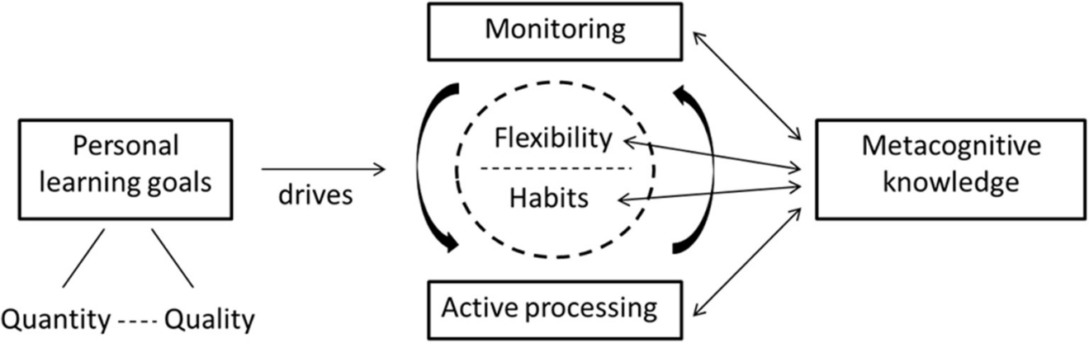
THEORETICAL FRAMEWORK
Fig. 1. Bjork’s Desirable Difficulties Framework (DDF). [64]

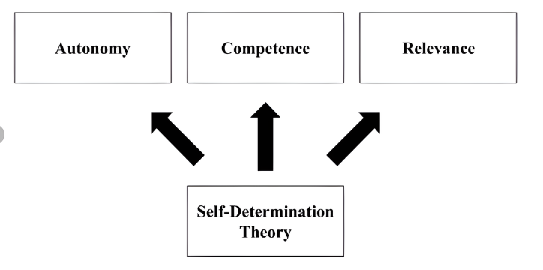
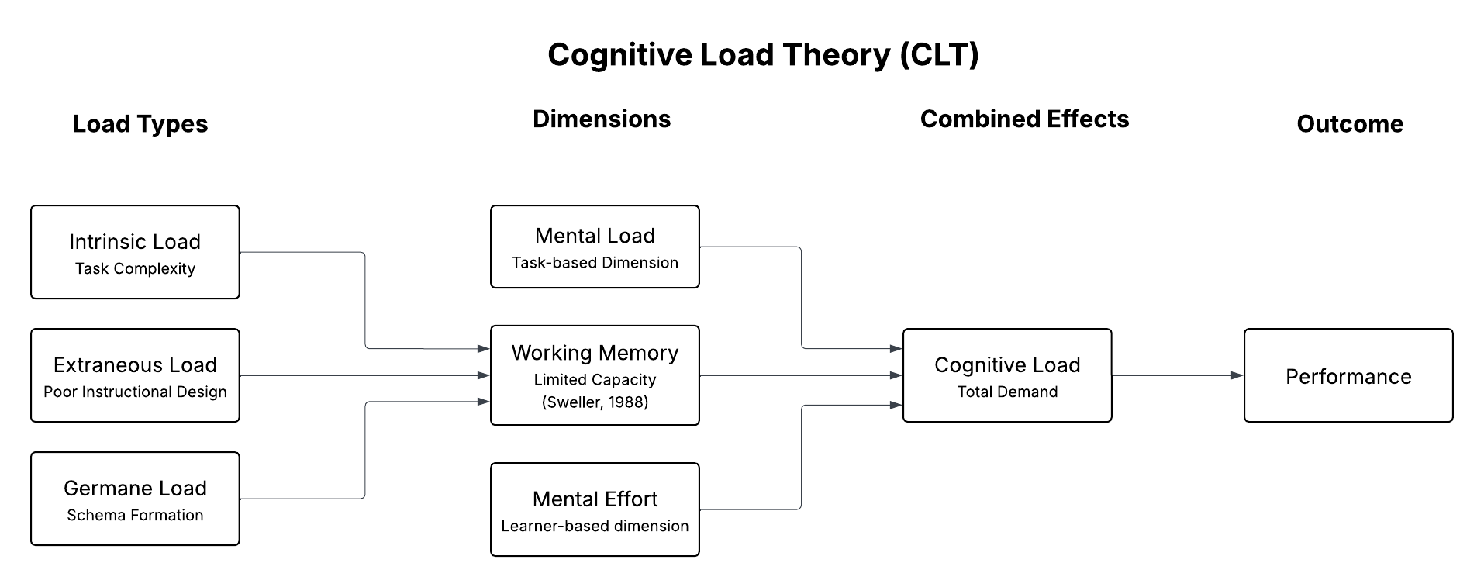
Fig. 2. Cognitive Load Theory (CLT). [65]
Fig. 3. Self-Determination Theory (SDT). [66]
The researchers based CPAce on three recognized theories: Bjork's Desirable Difficulties Framework, Cognitive Load Theory, and Self-Determination Theory (SDT). Each theory corresponds to a key characteristic of the system, and together they describe how CPAce supports effective, sustained, and personalized review for accounting students preparing for the CPALE exam.
Bjork's Desirable Difficulties Framework, developed by Robert Bjork in 1994, states that learning situations that needs a reasonable amount of cognitive effort during retrieval create more lasting and transferable long-term memory than conditions that make retrieval easy and painless [64]. The retrieval effort hypothesis is the framework's central mechanism: when a learner is required to reconstruct information from memory under moderate challenge conditions, such as retrieving material after a strategically timed delay, the act of retrieval strengthens the underlying memory trace and extends the period before forgetting occurs again.

This principle explains why spaced repetition and distributed practice consistently outperform massed or blocked studies in terms of long-term retention. Bjork's approach serves as the theoretical basis for CPAce's SM-2 Spaced Repetition Algorithm, which assigns each quiz topic for review at the exact interval before forgetting is expected to occur, depending on each student's demonstrated recall performance. Each scheduled retrieval is purposefully difficult: the delay is long enough to require genuine cognitive effort during recall, but not so long that the memory trace has completely vanished. The approach gradually consolidates CPALE topic information into long-term memory through repeated cycles of effortful retrieval at increasing intervals, guaranteeing that material reviewed months ago is still available at the time of the exam.
Sweller and Chandler's Cognitive Load Theory, which was expanded during their 1991 paper on instructional format, proposes that human working memory has a limited capacity to process new information at any given time, and that instruction that exceed this capacity impairs both learning and retention [65]. The theory splits cognitive load into three categories: intrinsic load, which refers to the material's inherent complexity; extraneous load, which refers to unnecessary cognitive effort caused by poor instructional design; and germane load, which refers to the constructive cognitive effort aimed at developing and integrating new knowledge schemas.
Effective instructional design lessen unneeded load while managing intrinsic load, clearing the learner's available working memory capacity for important processing. This theory supports CPAce's Adaptive Learning Engine and Weakness Detection Algorithm. By constantly examining each student's accuracy on each topic and guiding review sessions solely to areas where performance falls below competency levels, the system removes the cognitive waste of revisiting content that the student already understands. Instead of presenting uniform content throughout all six CPALE areas regardless of individual mastery level, CPAce focuses each session on the specific knowledge gaps where working memory investment results in the best learning return. This focused delivery reduces unnecessary cognitive load, maintains manageable intrinsic load via modular question sequencing, and clear the student's limited cognitive resources for the relevant processing required to merge truly unexpected material.
Edward L. Deci and Richard M. Ryan developed Self-Determination Theory (SDT), which identifies three fundamental psychological needs (autonomy, competence, and relatedness) that must be satisfied over time to maintain intrinsic motivation and long-term voluntary engagement in any activity [66]. Autonomy refers to the urge to perceive one's own actions as self-determined and self-directed rather than externally compelled. Competence refers to the desire to see oneself as capable and effective in one's actions, which requires both suitable challenge and relevant feedback on progress. Relatedness refers to the desire to feel really connected to those who share similar goals and values. When applied to educational technology, SDT predicts that learners will become more consistently and freely engaged with systems that provide all three of these demands simultaneously over time. The idea supports CPAce's gamification and community learning capabilities. The points system and success badges meet the competency requirement by providing students with clear, visible indicators of progress and proficiency. By giving each student, a constantly updated, subject-level visualization of their performance trends, accuracy rates, and review progress across all six CPALE subjects, the Personalized Analytics Dashboard further satisfies the competence need. By making individual progress visible and instantly actionable, the dashboard provides students with the precise feedback necessary to feel truly capable and to make evidence-based decisions about where to focus their remaining study effort (Calamlam [53]; Funa et al. [54]). By allowing students to assess their position in relation to their classmates while maintaining discretion over how and when they interact with review material, the leaderboards satisfy both competence and autonomy. The Community Hub, group messaging, and alumni mentorship directly meet the relatedness need by connecting students with peers who have the same high-stakes preparation goal and with alumni who can guide them. The CPALE review period can last several months, during which intrinsic motivation is especially vulnerable to attrition; SDT-grounded gamification design, as validated by Khaldi, Bouzidi, and Nader [21] and confirmed in the Philippine higher education context by Duterte [33] and Pajarito, Salcedo, and Fernando [22], provides the motivational architecture that sustains voluntary engagement over such a long period.
CPAce combines these three theories to produce three corresponding outcomes: durable long-term retention, based on Bjork's Desirable Difficulties Framework and operationalized through spaced retrieval scheduling; reduced and well-managed cognitive load, based on Cognitive Load Theory and operationalized through adaptive, weakness-targeted content delivery; structured self-regulated learning and sustained intrinsic motivation, based on Self-Determination Theory. Each theory addresses a separate and documented difficulty that accounting students have when studying for the CPALE, and each is directly incorporated in a specific system feature. The result is a theoretical framework in which each component of CPAce has both an empirical justification from the reviewed literature and a theoretical explanation from established learning science, all contributing to the overarching goal of improved CPALE readiness for Accountancy students at BatStateU-ARASOF Nasugbu.

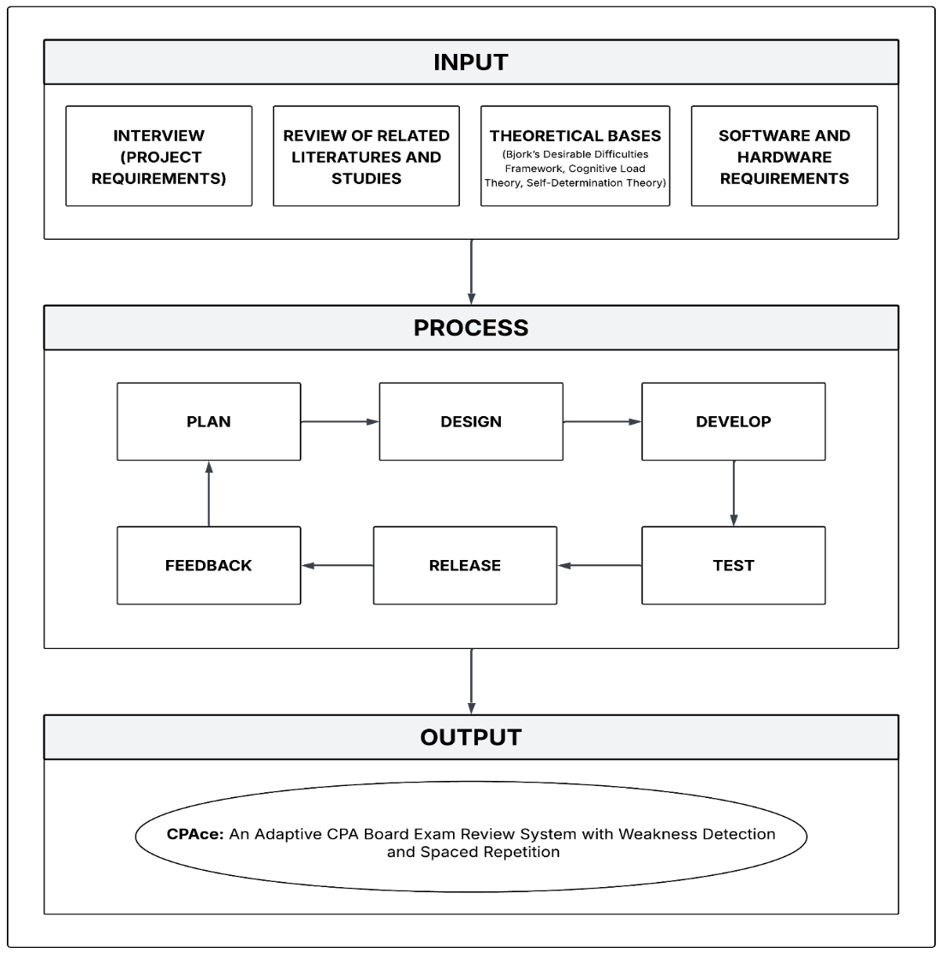
CONCEPTUAL FRAMEWORK
Fig. 4. Conceptual Framework of the Study.
The figure above showed the study's conceptual framework, including the input, process, and output requirements for system development. The input consists of four main components: the stakeholder interviews, the review of related literature and studies, the theoretical bases, and the software and hardware requirements. The process is guided by the Agile Software Development Life Cycle (SDLC), which covers the iterative phases of system development, from planning to feedback. The result is CPAce, a web-based adaptive review solution with spaced repetition scheduling, weakness identification, tailored analytics, a gamified community platform, and an AI-assisted content and curriculum management module meant to improve the CPALE preparedness of Accountancy students at BatStateU-ARASOF Nasugbu.
The input component of the framework includes the fundamental aspects that influenced and led the creation of CPAce. The project requirements were acquired through stakeholder interviews conducted with accounting students and faculty members at BatStateU-ARASOF Nasugbu. These tools were utilized to determine the target users' specific academic needs, review issues, and technology preferences, ensuring that the system was anchored in the context of its intended deployment. The information acquired throughout this process specified the system's functional and non-functional needs, as well as its scope and direction.
The second input element is the literature and studies review, which offered a theoretical and empirical foundation for the system's key features. The researchers examined peer-reviewed publications on adaptive learning, weakness identification, spaced repetition, learning analytics, and gamification, along with local research about academic problems that Filipino accounting students encounter when studying for the CPALE. This compiled material supported the use of the SM-2 Spaced Repetition Algorithm and Weakness Detection Algorithm as the system's major computational mechanisms, as well as the design of the gamification and community components. The review of related studies also identified a limitation in the existing review tools for CPALE applicants, highlighting how crucial the suggested system.
The third input element is the theoretical bases of the study, which are Bjork’s Desirable Difficulties Framework, Cognitive Load Theory, and Self-Determination Theory. These theories are discussed in the Theoretical Framework above. They explain the design of the spaced repetition scheduling, the weakness-targeted content delivery, and the gamification and community features of CPAce.
The fourth input element consists of the software and hardware requirements established during the planning phase. On the software side, the system was built with the Laravel framework as the primary full-stack web framework, PHP as the server-side scripting language, MySQL as the relational database management system, Bootstrap 5 for frontend design and responsiveness, and JavaScript for client-side interaction. The Google Gemini API, with OpenRouter as a fallback, provided the AI-assisted features, Laravel Socialite handled the Google and the dompdf, PhpSpreadsheet, and PhpWord libraries generated the PDF, Excel, and Word reports. Vite was used to bundle the front-end assets. Composer was used to handle the Laravel project's dependencies, and XAMPP served as the local development environment. The adaptive review engine's key computational components included the SM-2 Spaced Repetition Algorithm and a proprietary performance-based Weakness Detection Algorithm. On the hardware side, basic development workstations with internet access and a web-capable server environment were the minimum hardware requirements for development, testing, and deployment. A device with a working camera was also required for the proctoring feature.
The framework's process component is administered by the Agile Software Development Life Cycle (SDLC), which was chosen because of its iterative, adaptable, and user-centered software development methodology. The Agile methodology allowed the research team to constantly update the system depending on user feedback throughout the development cycle, assuring that the result stayed in line with the changing needs of the target consumers. The process is divided into six phases: planning, design, development, testing, release, and feedback, with implementation and evaluation marking the end of the cycle.
The planning process included formally defining the system's objectives, scope, functional requirements, and project deadline. During this phase, the research team consulted with stakeholders to decide the features to be produced in each iteration and establish the system's technical architecture. The design phase turned the collected requirements into system blueprints, which included the user interface and user experience design for all web pages, the entity-relationship diagram (ERD) and database schema for MySQL, and the algorithmic logic of the SM-2 Spaced Repetition and Weakness Detection components. The design artifacts created during this phase served as the foundation for all later development operations.
The development phase was the core technical implementation of the system, during which the research team built the CPAce platform using Laravel as the primary framework, with PHP handling all server-side logic, MySQL managing all persistent data, and Bootstrap 5 and JavaScript providing the responsive and interactive frontend experience. The SM-2 algorithm was programmed to dynamically compute inter-repetition intervals based on each user's performance score, and the Weakness Detection algorithm was encoded to continually check topic-level correctness and highlight underperforming subject areas for prioritization. Throughout this phase, the system's integral security components included user authentication, session management, role-based access control, CSRF protection, and bcrypt password hashing.
The testing phase included systematically verifying and validating all system capabilities using User Acceptance Testing (UAT) and functional testing with representative Accounting students and faculty evaluators. Testing activities evaluated the adaptive algorithms' correctness, the accuracy of the analytics dashboard, the security of user authentication procedures, the responsiveness of the interface across device kinds, and the general usability and dependability of the system. All faults and issues discovered during testing were documented and addressed before the system was moved on to the next step.
The release phase included deploying the tested system to its intended environment and formally presenting the platform to its target users at BatStateU-ARASOF Nasugbu. The feedback phase began soon after release, during which user answers, evaluator ratings, and performance statistics from actual system use were collected and examined to find areas for further modification. In keeping with the Agile methodology's iterative nature, the insights gained during the feedback phase were fed back into the planning and design phases to inform following development cycles, ensuring that the system is continuously improved. The last phase of implementation and evaluation included the evaluation of the deployed system through Apache JMeter benchmarking, which measured performance efficiency, and User Acceptance Testing (UAT), which verified the functionality of the system.
The framework's output is CPAce: An Adaptive CPA Board Exam Review System with Weakness Detection and Spaced Repetition, a fully functional, web-based adaptive review platform intended to address the reported flaws in existing digital preparation resources for CPALE candidates. The system's main output capability is the Adaptive Review Engine, which combines the SM-2 Spaced Repetition Algorithm and a custom Weakness Detection Algorithm to provide personalized, data-driven review sessions that dynamically adjust content sequencing, review intervals, and topic prioritization based on each student's continuously updated performance profile across all six CPALE subjects.
CPAce's second main output is its Personalized Analytics Dashboard, which provides each student with a clear, view of their performance patterns in real-time, accuracy rates for each subject, and progress across the CPALE test coverage. This dashboard transforms raw performance data into meaningful study insights, allowing students to make data-driven decisions about how to spend their remaining time to review and identifying the exact subtopics that require immediate attention. The Program Chair and faculty are also given a supervision dashboard that collects class-level performance data to help with instructional monitoring and intervention.
The Gamified Community Platform is the third major output and it includes game design elements such as a points system, achievement badges, leaderboards, and a Community Hub with group messaging to keep students motivated and promote collaborative learning throughout the extended CPALE review period. This feature addresses the psychological needs for competence, autonomy, and relatedness identified by Self-Determination Theory, giving students a socially connected and motivationally supportive review environment to supplement the system's personalized adaptive learning components.
The AI-Assisted Content and Curriculum Management Module is the fourth major output. It includes the AI Tutor, AI question drafting and paraphrasing for faculty, the import of the PRC Table of Specifications (TOS), curriculum versioning with an audit trail, and proctored quizzes and mock examinations. All AI-generated content is reviewed by the faculty or the Program Chair before it is published. This module helps faculty and the Program Chair keep the question bank aligned with the CPALE coverage while supporting the adaptive review of students.
The input, process, and output components of this conceptual framework, when combined, form a cohesive and research-based approach for the development and deployment of CPAce. The inputs provide the empirical and technical foundation for the system; the Agile process ensures that development is iterative, user-responsive, and quality-assured throughout its lifecycle; and the output is a purpose-built adaptive review platform that directly addresses the CPALE readiness needs of Accountancy students at BatStateU-ARASOF Nasugbu. The framework thus serves not only as a development guide, but also as a conceptual expression of how the proposed system blends established memory, instructional design, and learner motivation theories into a unified and easily deployable educational technology solution.

SYNTHESIS
The literature presented in this chapter consistently identifies four interconnected characteristics that constitute effective digital learning in high-stakes academic settings: personalization, spaced practice, data-driven feedback, and sustained learner motivation. These elements do not present in isolation throughout the conceptual literature, associated studies, and theoretical frameworks; rather, they reinforce one another, and research reveals that their combined presence in a learning platform achieves outcomes that no single strategy can achieve alone.
According to Du Plooy, Casteleijn, and Franzsen [3] and experimentally demonstrated by Christodoulou and Angeli [37], personalized adaptive learning consistently outperforms uniform instruction because it tailors content to each learner's demonstrated knowledge rather than assuming everyone starts from the same place. Spaced repetition, based on the spacing effect and validated by Fallah et al. [26], Martinengo et al. [17], Santhosh et al. [38], and Bego et al. [18], improves long-term retention by scheduling review at the exact moment before forgetting occurs, a function that is especially important in multi-subject, multi-month examination preparation such as the CPALE.
Data-driven feedback, as presented by Parmigiani et al. [27], Ong and Despi [28], Sharif and Atif [23], and Avillanoza et al. [30], transforms raw performance data into study decisions that learners may act on right away, and sustained motivation, as supported by Duterte [33], Li [34], Zeng, Ma, and Shi [19], Pajarito, Salcedo, and Fernando [22], and Khaldi, Bouzidi, and Nader [21], is most reliably maintained not through novelty, but through gamification based on Self-Determination Theory [66], specifically through designs that meet learners' needs for competence, autonomy, and belonging over time. The literature as a whole paints a picture of a unified design logic: efficient digital review requires personalization, spacing, targeted feedback, and motivating structure all working in tandem on a single, coherent platform.
Despite the strength of this evidence, the examined literature reveals a clear and substantial gap: no existing platform integrates these components into a system created expressly for the CPALE and the Filipino accounting students who must pass it. While the overseas studies were thorough and broad in scope, they were conducted in settings that bore little relation to the operational realities of BatStateU-ARASOF Nasugbu students. They fail to account for the CPALE's six-subject structure [11], [14], the exam's continuously poor passing rates [12], or the unique problems that Filipino online learners encounter.
Abeysekera [25] discovered that cognitive overload caused by poor instructional design decreases retention among Filipino online accounting students, which gets worse by unstable internet connections and household chores that interfere with study time. Briones et al. [43] confirmed that the same challenges of unstable internet, limited gadgets, and competing home responsibilities are common for Filipino college students and cannot be solved only by providing digital tools. Calamlam [53] and Funa, Gabay, Deblois et al. [54] discovered that structured self-regulation, instead of knowledge or motivation, separates high and low performers among Filipino online learners: students who track their progress, manage their time, and seek targeted feedback perform significantly better, regardless of their starting ability. Despite accurately recognizing these problems, the local literature fails to provide solutions. Ganas and Russell [46] discovered that personal study habits and independent motivation are far more crucial for CPALE success than formal coursework. Camacho et al. [29] discovered that structured mock examinations predict actual licensure performance with a R² of.474. However, none of the studies developed a tool to establish these habits or deliver examinations in an adaptive and personalized format. Cua et al. [44] concluded that neither purely online nor hybrid course delivery effectively prepares Accountancy students for the CPALE and specifically recommended purpose-built, review tools that are aligned with the examination, whereas Aniceto et al. [45] discovered that students who see the CPALE as a clear and immediate goal are more likely to seek structured practice that is precisely the type that no localized adaptive platform currently provides. In short, the difference is not due to a lack of understanding about what works. It is a disparity between what the research suggests should exist and what actually occurs.
Every significant aspect of CPAce is a direct reaction to a particular discovery from the literature review, and because of this mapping, the system's design decisions are not arbitrary but rather essential. The SM-2 Spaced Repetition Algorithm is based on Bjork's Desirable Difficulties Framework [64], which maintains that effortful retrieval under strategically timed delays results in more durable long-term memory than massed or effortless practice. It has been empirically validated by Fallah et al. [26], Martinengo et al. [17], Santhosh et al. [38], and Bego et al. [18], who collectively confirm that spaced, distributed practice results in a variety of technical and professional fields. These advantages are particularly significant for the six interconnected subjects of the CPALE, which must be retained concurrently over a period of several months. The Weakness Detection Algorithm is grounded in Cognitive Load Theory [65], which holds that working memory is finite and that instruction must minimize unnecessary cognitive effort to allow genuine learning to occur; by continuously monitoring per-topic accuracy and directing each review session only toward demonstrated knowledge gaps, the system eliminates the cognitive waste of reviewing what a student already knows, a design principle reinforced by Létourneau et al. [39], Lin, Huang, and Lu [52], and the local finding of Abeysekera [25] that Filipino online learners are especially vulnerable to instructional designs that overload working memory. The Learning Analytics Dashboard implements the useful suggestions of Sharif and Atif [23], Avillanoza et al. [30], Calamlam [53], and Funa, Gabay, Deblois et al. [54] that Filipino online learners require transparent, continuously updated progress-tracking tools to sustain self-regulated study over time. It also addresses the crucial finding of Ouyang et al. [40] that AI-generated performance predictions only improve learning outcomes when made visible through a real-time dashboard that students can act upon. The Gamification and Community Learning features are grounded in Self-Determination Theory [66], Ryan and Deci’s framework for intrinsic motivation and are designed specifically to meet all three of its core psychological needs: autonomy through self-paced review control, competence through points, badges, and progress visibility, and relatedness through the Community Hub, group messaging, and alumni mentorship; this SDT-based design is validated by Khaldi, Bouzidi, and Nader [21], who identified SDT-grounded gamification as consistently more effective than basic game mechanics, and by Duterte [33], Pajarito, Salcedo, and Fernando [22], and Lampropoulos and Sidiropoulos [20], who confirmed durable performance and engagement gains from gamification among Philippine and international higher education students. Finally, the system's adaptive question bank, which is aligned to the format, difficulty, and coverage of the CPALE, directly applies to Camacho et al.'s [29] discovery that mock board examination scores determine approximately 47% of the variance in actual licensure outcomes, making practice aligned to examination the single most impactful intervention any review platform can provide.
CPAce contributes to the field of educational technology and Philippine accounting education by providing what the reviewed literature has identified as a need but has yet to produce: a localized, CPALE-aligned, adaptive review system that combines established learning science into a practical and accessible tool for accounting students. Its contribution is more than just technical; it is the translation of a decade of educational research into a format appropriate for the pupils it is intended to serve. Whereas international systems demonstrate what adaptive learning can do in well-resourced settings, CPAce applies the same principles to the bandwidth limitations, device constraints, and self-regulation challenges that Abeysekera [25], Briones et al. [43], Calamlam [53], and Funa, Gabay, Deblois et al. [54] have documented as the everyday realities of Filipino online learners. Where local Philippine research identifies what CPALE candidates require—structured practice, individualized feedback, autonomous study help, and continuous motivation—CPAce delivers the technical infrastructure to provide those needs directly.
CPAce does more than just add another digital tool to the context; it integrates spaced repetition, adaptive personalization, automatic weakness detection, real-time analytics, and SDT-grounded gamification into a single platform based on the CPALE's six subjects, format, and standards. It bridges a specific, well-documented, and significant gap between what the research says is possible and what Filipino Accountancy students at BatStateU-ARASOF Nasugbu currently have access to, and it does so by providing a model for how established learning science can be applied with contextual precision to one of the most high-stakes educational challenges in the Philippine professional licensing system.

CHAPTER III
DESIGN AND METHODOLOGY
This chapter discusses the methodology of the study, including the research design, development process, and implementation approach. It outlines the tools, techniques, and procedures used to ensure the system's effectiveness and reliability. Additionally, it describes the testing and evaluation methods employed to validate the proposed solution.

RESEARCH DESIGN
This study will employ the descriptive-developmental research design, which focuses on comprehending an existing issue and creating a technology solution to address it. This design is suitable for studies that involve the design and implementation of innovative systems, as this allows researchers to methodically develop and evaluate the effectiveness of new technologies in resolving specified issues. This approach will serve as a guide in developing CPAce: an Adaptive Board Exam Review System with Weakness Detection and Spaced Repetition for Accountancy students of Batangas State University TNEU ARASOF-Nasugbu.
The descriptive-developmental research design consists of several iterative phases which include the following: Planning, System Development, Testing, Deployment, and Evaluation. The process begins with the descriptive phase, which involves assessing the current challenges that accounting students experience in preparing for the CPALE exam, such as the absence of personalized and adaptive review resources on campus.
Following the descriptive phase, the development of the system will be carried out based on the findings gathered. This involves the design and development of CPAce, which contains a Weakness Detection Module, a Spaced Repetition Scheduler, and an Adaptive Quiz Engine, as well as supporting features including a CPALE Mock Examination Simulator, a Performance Dashboard, and a Question Bank Management Module. Throughout the development process, continuous testing and refining will be performed to ensure that the system functions as intended and is capable of meeting the needs of its target users.
To objectively evaluate the performance of the developed system, this study will utilize a quantitative approach utilizing benchmarking tools. Specifically, Apache JMeter and other performance testing tools will be used to assess the system's response time, throughput, scalability, and reliability under load. For functional validation, User Acceptance Testing will be undertaken using deliberately selected Accountancy students and BSA faculty evaluators who will run predefined test cases to ensure that the system functionality meets their actual needs and expectations.
This method will enable the collection of precise and measurable data that can be objectively interpreted to determine the system's overall technical performance and its readiness for actual academic deployment.

DESIGN STAGE OF THE PROCESS
The Software Development Life Cycle (SDLC) is a structured framework for guiding the systematic development of software systems, assuring efficiency, dependability, and high quality in the finished output. It gives a systematic strategy to reducing potential risks while making the best use of existing resources throughout the development process. The CPAce system will be built and implemented in this study utilizing an Agile development methodology.
Agile methodology promotes continuous feedback, iterative enhancement, and effective resolution of system issues. The development process of the system will be organized into six major phases.
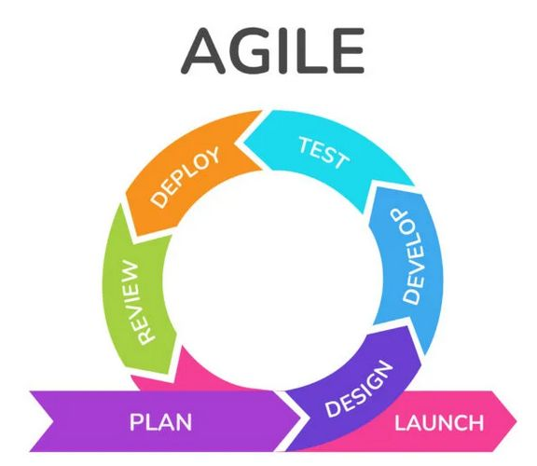
Fig. 5. Agile Methodology. [77]
Figure 5 illustrates the phases and processes of the Agile development methodology that will be utilized to complete the project. The Agile Software Development Life Cycle (SDLC) is an iterative and adaptable framework which enables evolving requirements while ensuring an organized, timely, and efficient development process. It is broken down into the following phases: planning/requirements, design, development, testing, deployment, and review.
The researchers will use the Agile methodology to create CPAce: An Adaptive CPA Board Exam Review System with Weakness Detection and Spaced Repetition.
Through the implementation of Agile, the researchers will use the Agile methodology to develop CPAce: An Adaptive CPA Board Exam Review System with Weakness Detection and Spaced Repetition. The deployment of Agile will allow the research team to incrementally create and improve the system while gradually incorporating its vital features. These include adaptive tests, weakness detection, spaced repetition scheduling, and performance monitoring. This method will ensure that the needs of accounting students will remain central throughout the development process. Compared to traditional linear development models, Agile supports continuous validation and iterative improvements, which will help reduce risks and enhance the overall quality and functionality of the system.
Planning phase
The planning phase will be the first stage of the project, during which the system requirements will be collected from the target users, such as faculty members and accounting students. In order to identify typical challenges that students have when studying for the Certified Public Accountant Licensure Examination (CPALE), the researchers will gather pertinent data by assessing current online review platforms and examining relevant literature.
The analysis will reveal several key challenges, including students’ difficulty in identifying weak subject areas, the absence of personalized review strategies, and limited tools for monitoring review progress. Based on these findings, the researchers will identify the essential functionalities need for the CPAce system to successfully assist students in their CPALE preparation
Design Phase
During the design phase, the researchers will design wireframes, user interface layouts, system architecture, and early prototypes of the CPAce system. The design will prioritize the creation of a user-friendly and efficient platform that allows students to simply navigate the system and access review materials.
Various system models, including flowcharts and diagrams, will be constructed to demonstrate the system's structure and operational operations. Technologies like HTML, CSS, and Bootstrap will be used to ensure that the system interface is responsive and accessible across multiple devices. Furthermore, PHP and JavaScript will be used to enhance system functioning and user engagement. This phase will also include the development of essential system components such as adaptive quizzes, algorithms for detecting weaknesses, spaced repeat scheduling, and performance monitoring dashboards.
Development Phase
In the development phase, the CPAce system will be implemented through a series of incremental stages. The researchers will focus on building the system's fundamental features, such as quiz generation, adaptive review systems, user authentication, and progress tracking.
The system will be designed as a mobile-responsive, web-based platform that employs modern programming methods to assure scalability, dependability, and maintainability. The spaced repetition mechanism and a weakness identification algorithm will be combined to automatically identify topics that require further review. Additionally, a system database will be created to contain user accounts, quiz questions, review schedules, and performance statistics.
Testing Phase
During the testing phase, the developed system will go through a variety of tests to ensure that all capabilities work properly and meet the intended criteria. The researchers will assess the system's performance, usability, and dependability in order to detect and solve any potential faults or technical problems. This phase will ensure that the CPAce system will function as expected and will provide a stable platform for its intended users before deployment.
Deployment/Release Phase
Following successful testing, the CPAce system will be implemented in a live environment and made accessible to its intended users. The system will be introduced as a supplementary learning tool to help accounting students prepare for the CPALE. During this phase, the researchers will monitor the system to discover and resolve any operational concerns, guaranteeing a smooth and effective implementation.
Feedback/Review Phase
After deployment, students and faculty members will provide feedback on the system's usability, performance, and effectiveness in supporting CPALE preparation. The input will provide essential information about the user experience and general system functionality. The information obtained from this feedback will serve as the basis for further enhancements and refinements of the CPAce system. By adopting the Agile methodology, the researchers will facilitate continuous development and ongoing improvement of the system.
DEVELOPMENT PROCESS
The development of CPAce: An Adaptive Board Exam Review System with Weakness Detection and Spaced Repetition will follow a structured and methodical process that will begin with the identification of the project's goals, the collection of system requirements, and the establishment of clear development objectives. Throughout each phase, the researchers will ensure that every decision made during implementation is based on the actual requirements of the target users, which are accounting students and faculty of Batangas State University TNEU ARASOF-Nasugbu who are preparing for and supporting the CPALE review. The requirements will be thoroughly studied and translated into concrete software specifications that will serve as the primary guide throughout development. The process will begin with design and coding and continue through testing, debugging, and validation, with each stage directly contributing to the overall quality, reliability, and adaptable functioning of CPAce.
Testing Process
Prior to the deployment CPAce, the researchers will undergo a thorough testing process to identify and address any weaknesses, vulnerabilities, and functional issues that may prevent the system from reaching its intended results. This phase is critical for ensuring that the system's core features, such as the Weakness Detection Module, Spaced Repetition Review Scheduler, Adaptive Quiz Engine, CPALE Mock Examination Simulator, Performance Dashboard, and Question Bank Management module, will function reliably and in accordance with the specifications. Unit testing will be performed on each individual component or module to ensure that each feature functions as intended in isolation. System testing will next be performed to determine how these components work together as a cohesive unit, ensuring that data flows between the adaptive engine, user profiles, and quiz generation module are consistent and accurate. These testing procedures will allow the researchers to detect and correct issues before the system is made available to end users, ensuring that CPAce is both operationally robust and capable of providing a responsive and relevant review experience to accounting students.
Debugging Process
Once the testing phase is completed, the researchers will proceed with the debugging process, wherein all errors and inconsistencies identified during testing will be systematically examined, traced to their root causes, and resolved. This will involve a careful review of the system's codebase, particularly in areas relating to the SM-2 algorithm implementation, the real-time updating of student weakness profiles, and the adaptive difficulty calibration of the quiz engine, as these components will require precise logic to function correctly under varying user performance scenarios. Automated debugging tools will be utilized in alongside manual code inspection to verify that all defects are identified, and iterative re-testing will be conducted after each fix to ensure that corrected issues do not cause new errors elsewhere in the system. The debugging process will not only rectify problems, but will also improve overall system performance, data integrity, and security, notably in role-based authentication mechanisms and the preservation of student learning records. Before proceeding to the validation stage, the researchers will ensure that CPAce is stable, optimized, and capable of providing a seamless and accurate adaptive review experience.
Validation Process
During this phase, the CPAce system will go through a comprehensive validation process in which its performance, features, and general functionality will be reviewed through benchmarking with proven performance testing tools and methodologies. The researchers will utilize Apache JMeter to simulate concurrent user loads on the system and assess key performance indicators like response time, throughput, and error rate at various traffic levels. This benchmarking approach will allow the researchers to objectively analyze how effectively CPAce functions in realistic and stressful settings, ensuring that the system stays stable and responsive even when several users access the platform at the same time.
Beyond load testing, the benchmarking procedure will assess the functional accuracy of the system's core adaptive processes. The Weakness Detection Engine will be tested by running specified sets of quiz responses and ensuring that the generated weakness profiles correspond to the expected output based on the scoring methodology. The SM-2 algorithm implementation will be evaluated by ensuring that the generated review intervals match each student's recall accuracy ratings across numerous simulation sessions. These organized benchmarking techniques will show that CPAce's adaptive features are precise and consistent enough to provide reliable board examination review support.
All benchmarking results will be carefully evaluated and analyzed to discover areas for further optimization. Adjustments will be made to resolve performance bottlenecks and verify that the system's outputs meet the required accuracy and reliability standards. This validation procedure will ensure that CPAce is ready for final use as a reliable, evidence-based, and institutionally appropriate adaptive review platform for CPALE preparation at Batangas State University TNEU ARASOF-Nasugbu.

PROGRAMMING PROCEDURE
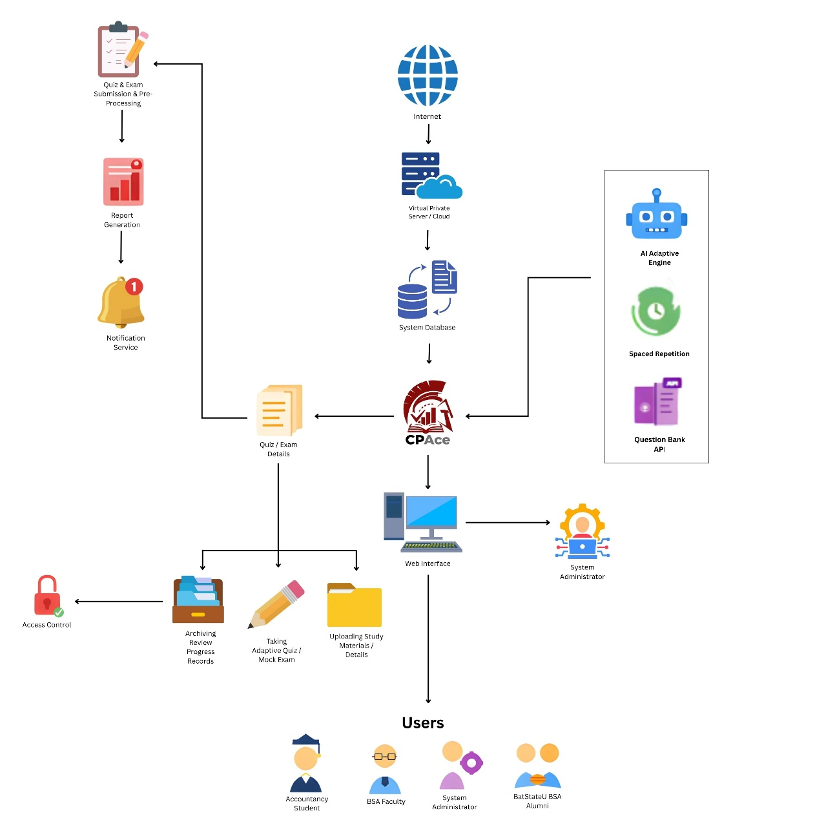
System Architecture
Fig. 6. System Architecture of CPAce
The figure presents the system architecture of CPAce: An Adaptive Board Exam Review System with Weakness Detection and Spaced Repetition. The application is hosted on a shared hosting accessed through the Internet, providing secure and remote access to all users. Within the server, CPAce incorporates several primary backend components: an Adaptive Review Engine, an AI Assistance Service, a Question Bank API, a Proctoring Service, a Curriculum Management Service, and a Messaging Service. The Adaptive Review Engine is rule-based. It combines the Weakness Detector, which detects student weaknesses and adjusts question difficulty based on individual performance, with the Spaced Repetition Scheduler, which schedules reviews using the SM-2 algorithm to improve long-term subject retention. The AI Assistance Service, which uses the Google Gemini API, supports the AI Tutor and the AI question drafting for faculty. The Proctoring Service records webcam captures and tab-switch and focus events during proctored quizzes and mock examinations. The Curriculum Management Service handles curriculum versions and the import of the Table of Specifications, and the Messaging Service handles direct and group messages. The Question Bank API contains all CPALE-aligned examination items organized by subject area, namely FAR, AFAR, MS, TAX, AUD, and RFBT, and is managed by authorized faculty members. These components support the core CPAce Review Management System, which is the main controller for all system functions. All processed data is stored and retrieved from the System Database, which has a bidirectional link to the CPAce core.
The Quiz and Exam Submission and Pre-Processing module, located on the architecture's left side, manages the initial intake of student submissions from users. The submitted quiz and exam details are sent to the CPAce core, which subsequently transmits it to the backend engines for processing and evaluation. From these processed records, the system generates performance dashboards and analytics on student progress and subject-level competency. A Notification Service then delivers alerts and status updates, such as quiz results, review reminders, and milestone notifications, to the concerned users to keep them informed of their learning progress.
Below the core application, access to the system is managed through a Web Interface. Access to this interface is controlled through an Access Control module that assigns user roles and permissions. The web interface is linked to three functional modules: Taking Adaptive Quiz and Mock Exam, which allows students to participate in personalized practice sessions and timed board exam simulations; Uploading Study Materials and Details, which allows users to contribute and access shared resources via a collaborative library; and Archiving Review Progress Records, which saves completed session histories and performance data for long-term academic monitoring.
The architecture supports four user groups: Accountancy Students, BSA Faculty, the Program Chair, and the BatStateU BSA Alumni. All of these user access CPAce through the mobile and web interface, but their capabilities are governed by the access control policies defined in the Access Control module. General users may take quizzes, upload materials, and track their progress, while higher-privilege roles such as faculty and the Program Chair may manage content, review analytics, and manage the curriculum and sections. This role-based design, combined with adaptive learning, spaced repetition scheduling, AI-assisted features, and notification services, ensures that CPAce delivers a secure, personalized, and effective preparation platform for the CPA Licensure Examination.
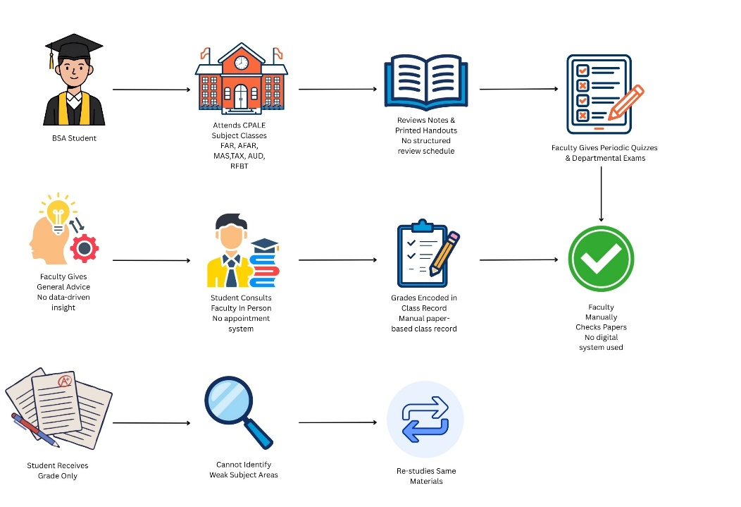
Requirements Analysis
Fig. 7. Requirements Analysis of CPAce
Figure 7 shows how BSA students and faculty currently handle the review and assessment process for the CPA Licensure Examination without the use of any digital system. In this traditional setup, students attend their CPALE-aligned subject classes, which include Financial Accounting and Reporting (FAR), Advanced Financial Accounting and Reporting (AFAR), Management Services (MS), Taxation (TAX), Auditing (AUD), and Regulatory Framework for Business Transactions (RFBT), one subject at a time each semester. After each class, students rely solely on the handwritten notes and printed handouts given by their professors to study on their own. There is no structured review schedule, no personalized guidance, and no tool to help students determine which subject areas they need to focus on the most. This method is entirely dependent on the student's own initiative and self-discipline, which can be inconsistent and difficult to maintain, especially across multiple demanding subjects.
When faculty members administer periodic quizzes and departmental examinations, the entire process of verifying and recording is done manually. Following the exam, professors manually review each paper, calculate scores, and enter the grades into a physical class record. This takes a significant amount of time, especially in large classes, and increases the risk of errors in recording. Because all performance data is recorded on paper, educators have no centralized means to track which students are regularly suffering across different CPALE areas. When students seek advise, they must make personal visits to their professors, and the counsel they receive is generalized in nature because it is not based on any documented performance data. This makes it challenging for professors to give timely and targeted academic interventions, particularly when multiple students require assistance at the same time.
When students receive their grades, they are just given their final grade, with no explanation of the specific themes or subject areas in which they performed badly. Without this information, kids are unsure how to improve. They frequently re-study the same subjects they are already familiar with, repeating poor study habits without realizing which areas require additional attention. This cycle continues throughout the entire BSA program, and by the time students face their qualifying examinations or approach their board exam preparation, many of them feel unprepared and unconfident. The absence of a system that analyzes individual deficiencies and evaluates progress over time makes it practically hard for students to study efficiently and professors to verify that each student is on track.
These constraints in the existing manual approach underline the importance of a digital and adaptive review platform. Problems such as the lack of tailored feedback, progress tracking, and reliance on paper-based records highlight the need for a more dependable and data-driven solution. A system like CPAce would enable students to identify their weak areas early on, adhere to an organized and personalized review program, and track their own progress over time. Faculty and review coordinators would also benefit from real-time visibility into student performance, allowing them to create more effective interventions and support programs. By filling these existing gaps, CPAce hopes to offer a more efficient, organized, and successful preparation environment for the CPA Licensure Examination.
Use Case Diagram
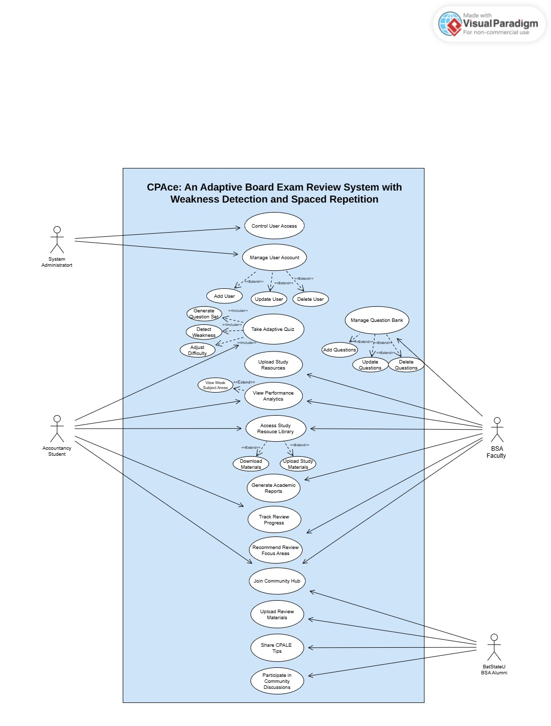
Fig. 8. Use Case Diagram of CPAce
Figure 8 shows the use case diagram of CPAce: An Adaptive Board Exam Review System with Weakness Detection and Spaced Repetition. The diagram illustrates four actors who interact with the system: the Accounting Student, the BSA Faculty, the Program Chair, and the BatStateU BSA Alumni. Each actor is assigned a specific set of functions based on their position in the review process, which includes adaptive quiz management, question bank administration, resource sharing, performance monitoring, and community engagement.
The Accountancy Student is the primary user of the system, with access to the most functionality. When a student takes an adaptive quiz, the system generates a series of questions, detects weak subject areas, and automatically modifies the difficulty of the following items based on the student's responses. Students can also upload study materials, track their own performance using the analytics dashboard, and expand this view to investigate their individual weak areas for each CPALE subject. Aside from tests, students can use the Study Resource Library to download available resources, create academic reports, track their review progress over time, and receive individualized advice on which topic areas to emphasize. Students can also participate in the Community Hub, which allows them to post review materials, share CPALE-related insights, and engage in academic debates with their peers, instructors, and alumni. Students can also chat with the AI Tutor, take proctored quizzes and mock examinations, manage their review notes, send messages, and plan their study schedule in the calendar.
BSA faculty use the system primarily to handle academic content and track student achievement. They are permitted to manage the Question Bank, which includes adding new examination items, modifying old questions, and removing outdated content from all CPALE disciplines. Faculty can also add study materials to the Study Resource Library for student usage, evaluate individual and class performance metrics, and generate academic reports to help with instructional planning. Faculty can also generate AI question drafts, monitor proctored sessions, import questions, and export the test bank. Their access to the Community Hub allows users to share knowledge while also staying connected to the platform's larger academic community.
The Program Chair oversees the curriculum and the quality of the review content of the program. This actor can manage curriculum versions, import the Table of Specifications (TOS), manage sections, import and export student records, and view program analytics. The Program Chair also sets up student accounts through the CSV import and OTP verification, so that only authorized users can access the system. The Program Chair can also review mock examinations, oversee faculty, and review AI-generated questions before they are published.
BatStateU BSA Alumni provide practical expertise and mentorship throughout the system. Alumni can contribute to the Study Resource Library, offer CPALE advice, post review materials, and actively participate in Community Hub conversations based on their board examination experience. Their participation provides a peer-driven layer to the platform, providing current students with real-world insights that go beyond what is offered in traditional classroom training.
The use case diagram of CPAce provides a clear and organized view of how the system serves each of its users. By allocating specific functions to each actor based on their role, the diagram guarantees that the platform runs smoothly and safely. It also helps developers identify the functional requirements that must be implemented to support the system's full scope, with the common goal of improving board examination readiness among BSA students through personalized, data-driven, and community-supported review.
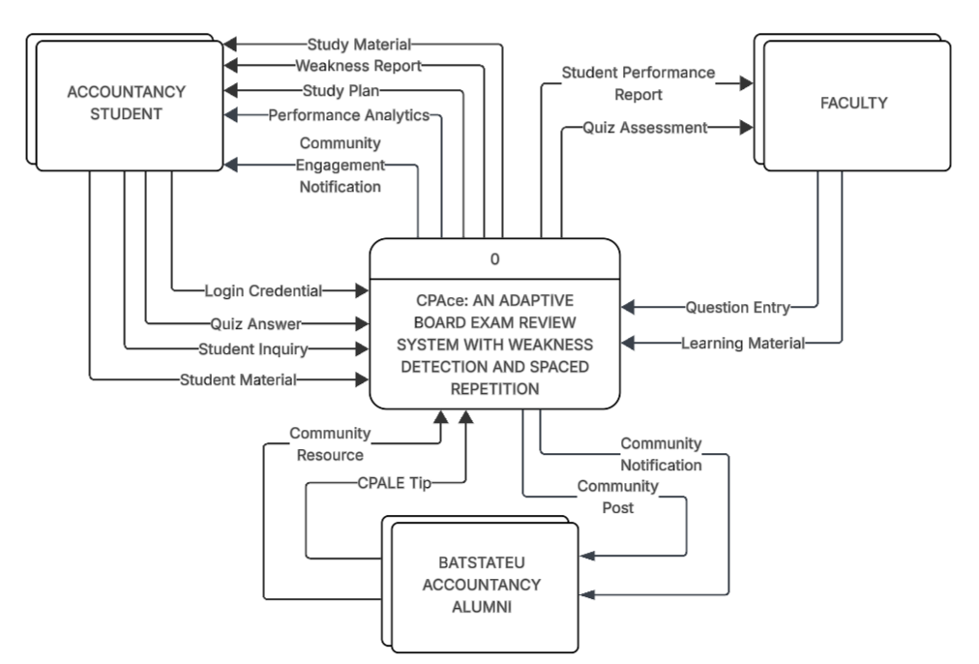
Context Diagram
Fig. 9. Context Diagram of CPAce
Figure 9 illustrates the interactions between the system and its major stakeholders in support of board examination preparation and academic engagement. CPAce serves as a centralized platform that manages review materials, assessment modules, performance metrics, and community knowledge exchange. By integrating educational resources, data-driven analytics, and communication tools, the system is designed to facilitate targeted learning and optimize the preparatory process for accountancy students.
The Accountancy Student is the primary user of CPAce. Students interact with the system using login credentials, quiz responses, student inquiries, and student materials. In response, CPAce provides study materials, weakness reports, study programs, performance statistics, community involvement, and notifications. These outputs allow students to identify areas of weakness and strategically direct their study efforts, improving the effectiveness of board test preparation.
Faculty members play important roles in the system as academic contributors. They contribute question inputs and learning resources that are incorporated into the system's learning modules. CPAce also provides faculty members with student performance reports and quiz evaluations, allowing for continual monitoring of learning progression and evaluation of educational effectiveness.
The BatStateU Accountancy Alumni community serves as an auxiliary stakeholder, offering professional insights and practical knowledge that augment the academic experience of current students. Alumni contribute community resources and CPALE tips, while the system enables them to receive community notifications and community posts. This bidirectional interaction fosters mentorship, knowledge sharing, and sustained engagement within the accountancy community.
The Program Chair is another external entity of the system. The Program Chair sends curriculum versions, Table of Specifications files, and review decisions on AI-generated questions to CPAce, and receives program analytics and mock examination reports in return.
CPAce also exchanges data with an external system, the AI Service (Google Gemini API). CPAce sends prompts, such as the study queries of students and the question content used for drafting, and the AI Service returns the generated content. This content is used by the AI Tutor and for AI question drafts.
Collectively, these stakeholder interactions establish CPAce as a primary focus for academic review and collaborative learning. The system facilitates the delivery of instructional materials, performance tracking, and professional coaching, ensuring that students receive comprehensive support during their board test preparation. The context diagram emphasizes CPAce's role in fostering a successful and collaborative educational environment through the integration of adaptive learning methodologies, data-driven analytics, and community participation.

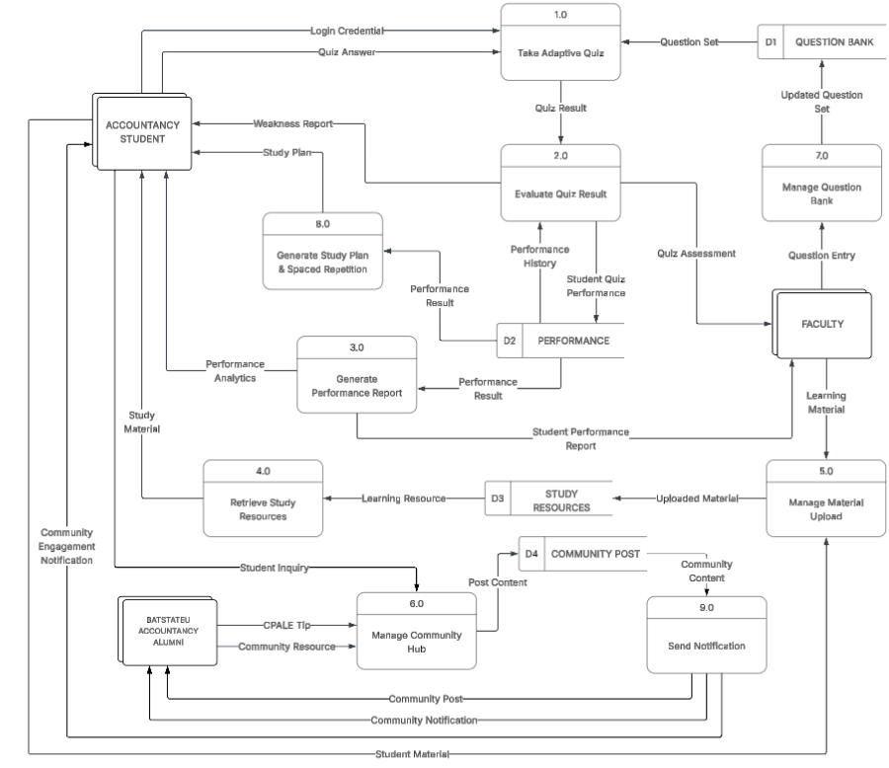
Diagram 0
Fig.10. Diagram 0 of CPAce
Figure 10 presents the Level 0 Data Flow Diagram (DFD) of CPAce: An Adaptive Board Exam Reviewer with Weakness Detection and Spaced Repetition, illustrating how the system processes adaptive quizzes, evaluates student performance, manages learning resources, facilitates community engagement, and generates personalized study plans. The system coordinates multiple learning and content management processes involving Accountancy Students, Faculty Members, and BatStateU Accountancy Alumni, supported by several internal data stores such as the Question Bank, Performance, Materials and Community Resources, and Community Post.
The process begins with the Accountancy Student, who logs into the system by submitting login credentials and participating in adaptive assessments through the Take Adaptive Quiz (1.0) process. The system retrieves questions from the Question Bank (D1) and presents them as a question set to the student. After completing the quiz, the student's answers are transmitted to the Evaluate Quiz Result (2.0) process, where the system analyzes quiz outcomes and generates the corresponding quiz results. The evaluation also considers the student’s performance history stored in Performance (D2)to dynamically adjust the level of difficulty for future quizzes.
Following evaluation, the system records the results in the Performance (D2) data store. These stored records serve as the foundation for generating analytics and monitoring learning progress. Through the Generate Performance Report (3.0) process, the system analyzes performance data and produces detailed performance analytics and student performance reports that are delivered to both students and faculty members for monitoring academic progress and identifying knowledge gaps.
To support continuous learning, students may access educational materials through the Retrieve Study Resources (4.0) process. This module retrieves learning resources from the Materials and Community Resources (D3) data store, which contains uploaded review materials such as CPALE guides, lecture notes, and practice exercises. The resources are uploaded and maintained through the Manage Material Upload (5.0) process, where Faculty Members contribute educational materials that are then stored and made available to students for independent study.
CPAce also promotes collaborative learning through the Manage Community Hub (6.0) process. In this module, students can submit student inquiries or participate in discussions, while BatStateU Accountancy Alumni contribute valuable CPALE insights, tips, and community resources. These contributions are stored in the Community Post (D4) data store and shared within the learning community to encourage knowledge exchange and mentorship.
The Manage Question Bank (7.0) process is handled by Faculty Members, who provide question details used to update and maintain the Question Bank (D1). This ensures that quiz content remains accurate, updated, and aligned with CPALE examination standards. Faculty members also review quiz assessments and student performance reports, enabling them to evaluate learning trends and improve question sets accordingly.
To further support personalized learning, CPAce includes the Generate Study Plan and Spaced Repetition (8.0) process. This module analyzes student performance records and identified weaknesses to generate a customized study plan and implement spaced repetition strategies. The resulting study plan is sent to the student along with a weakness report, helping them focus on topics that require additional review.
The Send Notifications (9.0) process ensures that users remain informed about important system activities. Notifications are triggered by events such as community posts, material uploads, due-review reminders based on the spaced repetition intervals, and community updates, and are distributed to students, faculty members, and alumni to keep them engaged within the platform.
The Manage Curriculum and Test Bank Coverage (10.0) process is handled by the Program Chair, who maintains curriculum versions and imports the Table of Specifications. The process checks the Question Bank (D1) against the curriculum and reports the topics that do not have enough questions.
In the Monitor Proctored Session (11.0) process, the system records webcam captures and tab-switch and focus events during proctored quizzes and mock examinations. Faculty and the Program Chair can view the session records and the risk-score breakdown.
The Handle AI Assistance Request (12.0) process sends the study query of a student, or the question drafting request of a faculty member, to the external AI Service and returns the generated content. AI-generated questions are kept as drafts until they are reviewed by the faculty or the Program Chair.
The system relies on four primary data stores to maintain operational continuity. The Question Bank (D1) stores quiz questions used in adaptive assessments. The Performance (D2) maintains student quiz results and difficulty adjustments used for analytics and personalized study planning. The Materials and Community Resources (D3) repository holds learning materials uploaded by faculty members and resources shared in the community. Meanwhile, the Community Post (D4) stores discussion posts, CPALE tips, and shared resources contributed by students and alumni.
Overall, the Level 0 DFD demonstrates how CPAce integrates adaptive assessment, performance analytics, personalized study planning, resource management, and collaborative learning into a single intelligent review platform designed to help Accountancy students prepare effectively for the CPA Licensure Examination (CPALE).

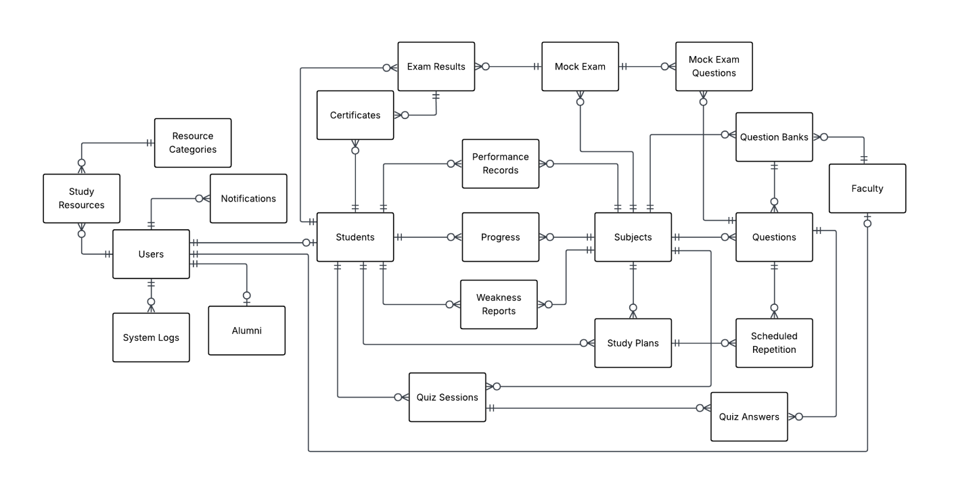
Entity Relationship Diagram
Fig. 11. Conceptual Entity-Relationship Diagram of CPAce
Figure 11 presents the Conceptual Entity–Relationship Diagram (ERD) of CPAce: An Adaptive Board Exam Reviewer with Weakness Detection and Spaced Repetition, illustrating how data is structured and interconnected across the system’s major modules: User Management, Assessment and Quiz Management, Performance Analytics, Learning Resources, Study Planning, Curriculum Management, Proctoring, and Communication.
The Users entity represents all users of the system, including students, faculty members, and alumni. It handles account information and is linked to Notifications and System Logs, which track system modifications and user activity. The Students entity stores student-specific data and is linked to Quiz Sessions, where students take adaptive quizzes and submit Quiz Answers.
Student responses are assessed and recorded in Performance Records, which measure learning results across many subjects. Based on these records, the system creates Weakness Reports to identify areas in which students can improve, and the progress of a student is derived from these records. These findings are then utilized to develop tailored Calendar Plans that are backed by Spaced Repetition Items, which use spaced repetition to promote learning.
The assessment component consists of Questions, which are grouped into Question Banks and managed by Faculty members. These questions are used in quizzes and mock exams to imitate actual CPALE testing situations. The results of these exams are recorded in Exam Results.
The system also incorporates Study Resources, which store learning materials organized by Resource Categories to enable structured learning. In addition, the Alumni Organization represents BatStateU Accountancy graduates who provide information and help to students preparing for the CPALE.
The ERD also includes the entities for the curriculum, assessment, and administrative modules. Sections, Faculty Subjects, and Faculty Subject Sections record which faculty members handle which subjects and sections. Curriculum Versions, Curriculum Audits, and Curriculum Import Batches support curriculum versioning and the import of the Table of Specifications, while Question Import Batches and Question Variants support the import of questions and the storage of alternate versions of questions. Faculty Quizzes, together with their Items and Attempts, and Mock Exam Registrations, together with their Items and Audits, store the class quizzes and mock examinations. Proctoring data is stored in Quiz Proctor Events and Captures and in Mock Exam Proctor Events and Captures.
For communication and student engagement, Conversations and Messages store direct and group messages, and Communications store announcements. Community Post Attachments, Likes, and Replies support the Community Hub, and Materials store the learning materials uploaded by faculty. Points Log, Badges, and Student Badges store the gamification records, Review Notes store the personal notes of students, and API Tokens support the token-based access of the mobile client.
Overall, the Conceptual ERD shows how CPAce uses adaptive assessments, performance monitoring, study resources, and personalized learning strategies to create an effective review platform for accounting students preparing for the Certified Public Accountant Licensure Examination (CPALE).

SOFTWARE AND HARDWARE NEEDED IN THE DEVELOPMENT
Software Requirements
TABLE I.
Software Needed in the Development
Software | Description | Specification
Operating System | OS platform used for developing and testing the system. | Windows 11
Web Server | Local server environment that runs the application during development. | XAMPP
Database Management System | Manages and persists all system data including user accounts, question bank entries, quiz results, and weakness profiles | MySQL
Programming Language | Languages used across the front-end and back-end layers of the system. | PHP, HTML, CSS, JavaScript
Framework | Structured back-end framework used for routing, authentication, and database operations. | Laravel
Dependency Manager | Manages the PHP libraries and packages used by the Laravel project. | Composer
Front-End Framework | Provides the prebuilt components and responsive grid used in the Blade views. | Bootstrap 5
Build Tool | Bundles the JavaScript and CSS assets of the project. | Vite
Authentication Library | Allows users to sign in with their Google account instead of a separate password. | Laravel Socialite (Google OAuth 2.0)
Code Editor | Integrated development environment used throughout the coding and debugging process. | Visual Studio Code
Web Browser | Browsers used for interface testing, compatibility checks, and system validation. | Google Chrome, Microsoft Edge
Algorithm Engine | Handles the computation of spaced repetition intervals based on the SM-2 algorithm, adjusting review schedules per student performance. | Custom SM-2 Logic (PHP)
AI Service | Provides the AI Tutor and the AI question assistance, with a fallback service when the main service is unavailable. | Google Gemini API (OpenRouter and Claude fallback)
Report and Document Libraries | Generates PDF, Excel, and Word reports and reads the PDF of the Table of Specifications. | dompdf, PhpSpreadsheet, PhpWord, smalot/pdfparser
Version Control System | Manages source code history and supports team collaboration during development. | Git / GitHub

Table I lists the software tools to be used in the creation of CPAce: An Adaptive Board Exam Review System with Weakness Detection and Spaced Repetition. Windows 11 will be used as the operating system due to its reliability and compatibility with the development tools needed for the project. XAMPP will be configured as the local server environment, allowing the team to execute and test the web application on individual PCs prior to any deployment activities, resulting in a controlled and reproducible setup that reduces environmental discrepancies during the development phase.
MySQL will be selected as the database management system because of its ability to handle relational data on the scale required by CPAce, which must manage student accounts, a categorized question bank covering all six CPALE subjects, individual quiz transaction records, weakness profile scores per topic, and spaced repetition scheduling data per user. Laravel will be used as the back-end framework to provide a structured and maintainable codebase. Its Eloquent ORM includes built-in features for user authentication, request routing, and database interaction, all of which are required to support the platform's role-based access model, which distinguishes students, faculty, program chairs, and alumni.
The front-end interface of CPAce will be built with HTML, CSS, JavaScript, and the Bootstrap 5 framework, which will determine the structure, style, and interactive behavior of pages like the adaptive quiz screen, the weakness trend dashboard, and the spaced repetition progress tracker. The entire development team will utilize Visual Studio Code as their code editor, thanks to its support for several programming languages, built-in terminal access, and vast plugin ecosystem that simplifies debugging and code navigation. During testing, Google Chrome and Microsoft Edge will be utilized simultaneously to ensure that the system's interface and functionality work consistently across multiple browser contexts.
Composer will manage the PHP dependencies of the project, and Vite will bundle the front-end assets. The Google Gemini API, with OpenRouter and Claude as fallback options, will power the AI Tutor and AI question assistance, and Laravel Socialite will handle the Google and Microsoft sign-in. The dompdf, PhpSpreadsheet, and PhpWord libraries will generate the PDF, Excel, and Word reports, and smalot/pdfparser will read the PDF of the Table of Specifications for import.
A custom implementation of the SM-2 algorithm, developed in PHP, will power CPAce's spaced repetition engine by determining the next ideal review date for each question based on how accurately a student remembered it. Git and GitHub will be integrated into the development workflow from the outset to track all codebase changes, maintain a version history, and allow team members to work on different features concurrently without conflict. These software requirements indicate the current setup for the development phase and are subject to change as the project progresses through the stages.
Hardware Requirements
TABLE II.
Hardware Needed in the Development
Hardware | Description | Specification
Computer System | Primary machine used by the developers for writing code, running the local server, and testing the system. | 2.5 GHz processor, 16GB RAM, 512GB SSD
Flash Drive | Portable storage used for backing up project files and moving resources between machines during development. | 64GB or higher
Mobile Phone | Device used to verify the system's layout and functionality on smaller screens across different mobile platforms. | Android/iOS, at least 4GB RAM
Webcam / Built-in Camera | Device used to test the browser-based proctoring feature, which captures webcam images during quizzes and mock examinations. | Built-in or external webcam
Keyboard | Standard input device used throughout the development and debugging process. | Mechanical/Membrane, Ergonomic
Mouse | Pointing device used for navigating the development environment and interacting with system interfaces. | Optical/Wireless, High DPI
Table II shows the hardware components that will be used to design and test the CPAce system. The computer system will serve as the project's primary development machine, and its specifications of a 2.5 GHz processor, 16GB RAM, and 512GB SSD will be determined to be sufficient for running XAMPP, a code editor, a web browser, and the MySQL database without performance degradation. Tasks like generating the adaptive quiz engine, conducting weakness detection computations, and populating the analytics dashboard all demand consistent processing availability, thus having enough RAM and storage performance is critical throughout the development phase.
A flash drive with a capacity of at least 64GB will be offered as a dependable method of backing up the project at critical development milestones and exchanging files amongst team members when direct network sharing is not possible. A mobile phone running Android or iOS with at least 4GB RAM is also included in the hardware setup, as CPAce will be accessed by accounting students across a variety of devices, necessitating the verification that the system's interface scales correctly and remains fully functional on mobile screen sizes commonly used by the target end-users. A webcam or a built-in camera is also required so that the browser-based proctoring feature can be tested. The keyboard and mouse will complete the hardware list as standard input devices used during all stages of development.

INSTRUMENTATION
This study will use a technical evaluation approach to analyze CPAce's performance, accuracy, and functionality. The researchers will use a descriptive-developmental research approach to evaluate the system against industry-standard benchmarking tools and automated testing frameworks. This approach will be selected to provide objective, reproducible, and measurable data that will accurately reflect the system's capabilities under controlled conditions, directly addressing the two primary evaluation objectives of the study: the functional correctness of the Weakness Detection Module and the Spaced Repetition Scheduler, and the performance of the system in terms of response time, throughput, scalability, and reliability under load, and the functional validation through UAT.
The development of CPAce will follow an Agile iterative methodology, wherein the system will be built, tested, and refined in incremental stages. Each iteration will concentrate on a single set of system features, allowing the researchers to discover and resolve problems before moving on to the next development phase. The evaluation phase will use a structured benchmarking process to rigorously assess the system's performance across all major quality parameters mentioned in the statement of objectives.
CPAce will be evaluated using a combination of performance benchmarking tools, automated functional testing frameworks (PHPUnit), custom Laravel Artisan evaluation commands, and information retrieval measures (precision, recall, and F1-score) will be used for algorithm validation.. The researchers will utilize these tools to acquire quantitative data that directly addresses the study's research concerns. Each instrument will be chosen based on its applicability to a certain system quality attribute and its widespread recognition in the software performance evaluation literature.

TABLE III.
Benchmarking Tools and Corresponding Metrics per Evaluation Area
Evaluation Area | Benchmarking Tool | Metric Measured | Output
Weakness Detection Accuracy | Automated Evaluation Commands + Ground Truth Dataset | Precision, Recall, F1-Score per CPALE Subject | Accuracy Report
SM-2 Algorithm Correctness | Unit Testing (PHPUnit) | Pass / Fail per SM-2 Interval Calculation | Functional Test Report
Response Time | Apache JMeter | Average Response Time (ms) | Performance Report
Throughput | Apache JMeter | Requests per Second (RPS) | Throughput Report
Scalability | Apache JMeter (Ramp-Up Test Plan) | Degradation Rate under Increasing Load | Scalability Report
Reliability under Load | Apache JMeter | Error Rate (%), Uptime under Stress | Stability Report
Functional Correctness (UI) | Playwright | Pass / Fail Test Cases per System Feature | Functional Test Report
API Endpoint Correctness | Postman | HTTP Status Codes, Response Body Accuracy | API Test Report

Table III will provide the mapping of each system evaluation area to its corresponding benchmarking tool and the metric that will be used to assess it. This organized approach ensures that every area of CPAce's performance and functional correctness is assessed using the most appropriate and reliable instrument. The tools and their respective functions in the evaluation of CPAce will be discussed in further detail in the following sections.
Apache JMeter
Apache JMeter is a popular open-source load and performance testing tool in software engineering. It simulates concurrent user requests and measures system response under varied loads. on this study, JMeter will be used to test CPAce on four performance dimensions: response time, throughput, scalability, and load reliability. Each scenario will have its own test plan, including a ramp-up test plan that simulates steadily growing numbers of concurrent users accessing the system's quiz engine, spaced repetition scheduler, and dashboard at the same time. JMeter will automatically record average response times, request throughput (in requests per second), error rates, and performance deterioration indicators, which may then be exported for statistical analysis.
Playwright
Playwright are browser-based automated testing frameworks that will be used to ensure the functionality of CPAce's online interface. Test scripts will be written to simulate real-world user interactions across all system roles, such as students taking adaptive quizzes and accessing the performance dashboard, faculty members managing the question bank and viewing cohort reports, and the Program Chair managing curriculum versions, sections, and student accounts. Each test case will be marked as Pass or Fail based on whether the system generates the desired output, providing a clear and quantitative signal of functional compliance across all important CPAce system characteristics
Postman
Postman is a prominent API testing platform that will be used to ensure the accuracy and dependability of application programming interfaces. The evaluation pipeline will employ Newman, Postman's command-line companion, to automate the execution of predefined API test sets. The researchers will develop test collections for all CPAce backend endpoints available in this study, such as quiz generation, student performance recording, SM-2 interval calculating, weakness profile retrieval, user authentication, and report generation. Each request will be evaluated using the returned HTTP status codes, the accuracy of the response body, and the tool's response time.
Unit Testing: PHPUnit
PHPUnit will be used to test CPAce's basic algorithmic components at the unit level, focusing on the SM-2 spaced repetition algorithm implementation and the Weakness Detection Module. For each test instance, the researchers will give a known set of input parameters, such as a student's easy factor, prior interval, and recall quality score, and will ensure that the system calculates the right next review interval according to the SM-2 formula. Similarly, the Weakness Detection Module will be validated against a preset dataset of student answer records to ensure that the system appropriately categorizes each CPALE subject domain's competency level and highlights weak areas for future evaluation.

Test Configuration Parameters
To ensure reproducibility and validity of benchmarking results, the following test configuration parameters will be established:
TABLE IV. Benchmarking Test Configuration
Parameter | Configuration
Concurrent User Loads | 10, 50, 100, 200 simultaneous users
Test Duration per Scenario | 5 minutes sustained load
Ramp-Up Period | 30 seconds
Acceptable Response Time | < 2000 milliseconds
Acceptable Error Rate | < 5%
Number of Test Iterations | Minimum 3 iterations per scenario
Test Environment | VPS with 4 vCPU, 8GB RAM, 100Mbps network

Ground Truth Dataset and Automated Evaluation Commands
The construction of the ground truth dataset is a critical component in objectively evaluating the accuracy of CPAce’s Weakness Detection Module and SM-2 Scheduler. For the Weakness Detection Module, a dataset of 120 predefined simulated student response scenarios is created and distributed across six CPALE subject areas: Financial Accounting and Reporting (FAR), Advanced Financial Accounting and Reporting (AFAR), Management Services (MS), Taxation (TAX), Auditing (AUD), and Regulatory Framework for Business Transactions (RFBT), with 20 scenarios allocated to each subject. Each scenario is purposefully created to represent a variety of performance levels, including clear deficiency, mastery, borderline, and mixed patterns. A topic is designated as a weak area when the simulated performance shows an accuracy rate of less than 60% across at least five quiz attempts within a specific topic, or when three consecutive incorrect replies occur within the same topic. The ground truth classifications are created algorithmically using these predefined criteria, ensuring that all predicted outputs are mathematically derived from input response patterns. This approach ensures that the validation process is objective, consistent, and reproducible, eliminating the need for subjective human judgment.
For the SM-2 Scheduler, a separate validation dataset of 204 test cases is created to cover all possible recall quality ratings from 0 to 5, as well as varying easiness factor histories. Each test case provides the expected review interval, which was determined using Piotr Wozniak's original SM-2 algorithm parameters. During the assessment phase, automated Automated Evaluation Commands are used to run all test scenarios by feeding predetermined inputs into the system and comparing the results to the matching ground truth values. The performance of the Weakness Detection Module is assessed using standard classification metrics, namely Precision, Recall, and F1-Score, while the SM-2 Scheduler is evaluated based on its exact match correctness rate. This fully automated validation framework ensures that the evaluation process remains quantitative, objective, and reproducible, consistent with the benchmarking-oriented methodology adopted in this study.

Evaluation Metrics and Formulas
The researchers will utilize several quantitative metrics to evaluate the performance and functional accuracy of CPAce. The following formulas will be applied to the data collected through the benchmarking instruments described in the preceding section. These metrics will collectively provide a comprehensive analysis of the system's effectiveness in delivering personalized, accurate, and performant CPALE review support.

Weakness Detection Accuracy: Precision, Recall, and F1-Score
The accuracy of CPAce's Weakness Detection Engine will be evaluated using Precision, Recall, and F1-Score computed against the ground truth dataset. Precision will measure the proportion of subjects flagged as weak by the system that are genuinely weak according to the ground truth. Recall will measure the proportion of truly weak subject areas that the system successfully identifies. The F1-Score will be the harmonic mean of Precision and Recall, providing a single balanced indicator of detection accuracy that will account for both false positives and false negatives simultaneously.
Precision = True Positives / (True Positives + False Positives)
Recall = True Positives / (True Positives + False Negatives)
F1-Score = 2 × (Precision × Recall) / (Precision + Recall)
where:
- True Positives = Subject domains correctly identified as weak by the system that were also flagged as weak in the ground truth
- False Positives = Subject domains incorrectly flagged as weak by the system that were not weak in the ground truth
- False Negatives = Subject domains that were weak in the ground truth but were not identified as weak by the system

SM-2 Algorithm: Spaced Repetition Interval Formula
The correctness of CPAce's Spaced Repetition Scheduler will be evaluated by verifying that the system accurately computes review intervals in accordance with the SM-2 algorithm developed by Piotr Wozniak. The SM-2 formula will determine the next review interval for each study item based on the student's recall quality score and the item's current ease factor, as follows:

I(1) = 1 day
I(2) = 6 days
I(n) = I(n−1) × EF, for n > 2
where:
- I(n) = The interval in days before the next review of the item at repetition n
- EF = The Ease Factor, initialized at 2.5 and updated after each review using the formula: EF' = EF + (0.1 − (5 − q) × (0.08 + (5 − q) × 0.02))
- q = The recall quality score given by the student after each review, ranging from 0 (complete blackout) to 5 (perfect response)
If the recall quality score q is less than 3, the item will be reset and repetition will restart from the beginning. The minimum value of EF will be bounded at 1.3 to prevent excessively short review intervals. Each unit test case will provide a known input set of prior interval, ease factor, and quality score, and will verify that the system computes the expected next interval within an acceptable tolerance, confirming the correctness of the SM-2 implementation in CPAce.

Average Response Time
The Average Response Time will be calculated to measure the speed of the system in processing and returning results for key user interactions, including quiz item loading, weakness profile retrieval, and dashboard data rendering. This metric will be recorded in milliseconds for each request submitted during JMeter test execution. The formula for computing the Average Response Time is as follows:
Average Response Time = ΣResponse Time / N
where:
- ΣResponse Time = Sum of all recorded response times across all test requests
- N = Total number of requests submitted during the test

Throughput
Throughput will be measured to determine the number of requests CPAce can successfully process per unit of time under a defined load. This metric will reflect the system's capacity to serve concurrent students during high-demand periods, such as the weeks immediately preceding the CPALE administration. Throughput will be recorded by JMeter in requests per second (RPS) for each test scenario and computed as follows:
Throughput = Total Number of Requests / Total Test Duration (seconds)

Scalability
Scalability will be assessed by measuring the rate at which CPAce's average response time degrades as the number of concurrent users is incrementally increased during the JMeter ramp-up test. The degradation rate will be computed to determine at what concurrency threshold the system's response time exceeds an acceptable limit, providing a quantitative indicator of the system's capacity ceiling. The formula for computing the performance degradation rate is as follows:

Degradation Rate (%) = [(RTₙ − RT₁) / RT₁] × 100
where:
- RTₙ = Average response time recorded at the highest concurrency level tested
- RT₁ = Baseline average response time recorded at the lowest concurrency level (single user)

Reliability under Load
Reliability under load will be evaluated by measuring the error rate of CPAce during sustained high-concurrency testing conducted using JMeter. The error rate will reflect the proportion of requests that the system fails to process successfully relative to the total number of requests submitted, providing a direct indicator of system stability under stress conditions. The formula for computing the error rate is as follows:
Error Rate (%) = (Number of Failed Requests / Total Requests) × 100
A lower error rate will indicate greater system reliability. The researchers will set an acceptable error rate threshold of less than five percent (5%) during sustained load testing as the benchmark for satisfactory reliability performance of CPAce.

PREPARATION AND EVALUATION
The researchers will prepare the evaluation environment prior to the execution of any benchmarking test to ensure consistency and fairness across all evaluation scenarios. A structured set of test cases, benchmarking scripts, and evaluation datasets will be prepared to serve as the primary instrument for collecting quantitative performance and accuracy data. This preparation will be aligned with the specific objectives identified in the statement of the problem, ensuring that each test will directly address a measurable research question corresponding to either the functional correctness or the performance of CPAce.
The preparation phase will involve the following key activities: configuration of Apache JMeter test plans covering response time, throughput, scalability, and reliability scenarios, including the definition of thread groups, ramp-up periods, and loop counts calibrated to simulate realistic concurrent student usage; development of Selenium and Playwright automation scripts covering all major system functionalities across all user roles; construction and validation of the ground truth dataset for the Weakness Detection Module, consisting of predefined student response scenarios paired with expected competency classifications; writing of PHPUnit unit test cases for the SM-2 algorithm implementation, each verifying a specific combination of input parameters against the expected computed interval; and setup of Postman test collections for all backend API endpoints with predefined request parameters and response assertions.
All benchmarking tests will be conducted in a controlled environment with consistent hardware and network conditions to minimize the influence of external variables. Test results will be logged automatically by the respective tools and exported for analysis. The collected data will then be processed using the formulas described in the preceding section to compute the final evaluation metrics. These metrics will provide a comprehensive and objective basis for assessing the effectiveness of CPAce as an adaptive CPALE review platform.

TABLE V.
System Functionality Evaluation Criteria for CPAce
System Feature | Evaluation Criterion | Test Output
Weakness Detection Module | Correctly identifies weak CPALE subject areas based on student performance history. | Pass / Fail + Precision & Recall scores
Spaced Repetition Scheduler (SM-2) | Accurately computes review intervals using the SM-2 formula and reschedules items. | Pass / Fail per interval calculation test
Adaptive Quiz Engine | Generates practice questions matched to the student's current weakness profile. | Pass / Fail per quiz generation scenario
Mock Board Examination Simulator | Replicates full-length timed CPALE conditions and feeds scores into the competency profile. | Pass / Fail + timing accuracy
Performance Dashboard | Displays accurate subject-level mastery scores, weakness trends, and readiness indicators. | Pass / Fail per dashboard data assertion
Question Bank Management | Allows authorized faculty to upload, tag, and categorize questions by subject and difficulty. | Pass / Fail per CRUD operation
Role-Based Access Control | Enforces correct access restrictions for Student, Faculty, Program Chair, and Alumni roles. | Pass / Fail per role-access test case
Score Reporting | Generates accurate individual and cohort performance reports. | Pass / Fail + data accuracy check
AI Tutor Response Handling | Returns a response to the study query of a student and continues to work through the fallback service when the main AI service is unavailable. | Pass / Fail per AI request scenario
AI Substitute Question Review Workflow | Keeps AI-generated substitute questions unpublished until they are approved by the faculty or the Program Chair. | Pass / Fail per review-status test case
Proctoring Event Capture and Risk Scoring | Records webcam captures and tab-switch and focus events during proctored sessions and computes the risk-score breakdown. | Pass / Fail per logged event and score
Curriculum Version and TOS Import | Imports the PRC Table of Specifications into a curriculum version and records the change in the audit trail. | Pass / Fail per import and audit test case
Messaging and Community Hub | Sends direct and group messages and allows posts, replies, and shared resources. | Pass / Fail per messaging and posting test case
Notification Delivery | Delivers system notifications to the intended users. | Pass / Fail per notification test case
Review Notification | Sends a reminder when a scheduled review session is due according to the spaced repetition interval. | Pass / Fail per due-review reminder scenario

Table V will present the functional evaluation criteria to be applied to each major feature of CPAce. Each criterion will define the specific behavior the system must demonstrate to receive a passing result, and the corresponding test output column will identify the form in which each result will be recorded. These criteria will serve as the basis for the Selenium, Playwright, and Postman test scripts to be developed by the researchers during the preparation phase.

ETHICAL CONSIDERATION
In conducting the proposed study, there will be multiple ethical considerations that will be observed to ensure compliance with data privacy, security, and research integrity. The researchers will strictly uphold the confidentiality of all student performance data and academic records accessed during the development and evaluation of CPAce. All test data to be used in the benchmarking process will either be synthetically generated for evaluation purposes or drawn from existing academic records for which proper institutional authorization will be obtained from Batangas State University TNEU ARASOF-Nasugbu. No personal data of individual students will be collected, processed, or disclosed beyond what is strictly necessary for the purposes of system testing and validation.
Before any data will be used in the evaluation, the researchers will ensure that all activities comply with the university's data governance policies and the provisions of the Data Privacy Act of 2012 (Republic Act No. 10173). All stored student performance records and examination-related data within CPAce will be protected by the system's role-based authentication and access control mechanisms, ensuring that sensitive academic information will be accessible only to authorized users. The integrity of the question bank will be safeguarded to prevent unauthorized access to examination items, preserving the validity of the CPALE mock examination feature.
CPAce uses an external AI service for the AI Tutor and for AI question drafting. Student prompts and question content are sent to Google Gemini, with OpenRouter as a fallback service. Only the text of the study query or the question content is sent. Names, email addresses, student numbers, and other personal information are not included. The processing of this data will follow the Data Privacy Act of 2012 (Republic Act No. 10173), and users will be informed that their AI Tutor messages are processed by an external service.
The browser-based proctoring feature captures webcam images, which will be treated as sensitive personal information under Republic Act No. 10173, otherwise known as the Data Privacy Act of 2012. Prior to the commencement of any proctored session, students will be informed of the purpose of the captures, which is to uphold academic integrity during quizzes and mock examinations, and their informed consent will be secured.
Access to the captured images will be restricted exclusively to the assigned faculty member and the Program Chair. The system will observe a strict data minimization policy wherein, upon submission of an attempt, all routine timer frames will be immediately deleted, and only the opening camera photograph will be retained as documentary evidence of the examinee's identity, together with any frames that substantiate a flagged integrity event. All remaining images will be automatically and permanently deleted by the system fourteen (14) days after the examination date, or earlier upon the resolution of the case by the assigned faculty member or the Program Chair. Only the behavioral event logs, which contain no images, will be retained beyond this period as the durable record of the session.
When users sign in through Google, CPAce receives only the basic profile information shared by the provider, such as the name and the email address. This information is used only to identify the user and to create or link the account. CPAce does not receive or store the passwords of these accounts.
To protect academic integrity, all AI-generated questions are reviewed by the faculty or the Program Chair before they are published to students. The AI Tutor is a study aid only and is not intended to provide answers during graded quizzes or mock examinations.
Furthermore, all references to existing algorithms, frameworks, and literature used in the development of CPAce will be properly cited and attributed to their original authors in accordance with academic integrity standards. The SM-2 algorithm will be credited to its original developer, Piotr Wozniak, and its implementation in CPAce will strictly adhere to the publicly documented specifications of the algorithm. Overall, these ethical practices will be intended to ensure that CPAce remains a trustworthy, secure, and academically responsible platform, while protecting the rights, privacy, and academic integrity of all students and stakeholders involved in the study.

REFERENCES
[1] J. Norcini and R. Guille, “Combining tests and setting standards,” in International Handbook of Research in Medical Education, G. R. Norman, C. P. M. van der Vleuten, and D. I. Newble, Eds. Dordrecht: Springer, 2002, pp. 811–834.
[2] M. Vandewaetere, P. Desmet, and G. Clarebout, “The contribution of learner characteristics in the development of computer-based adaptive learning environments,” Computers in Human Behavior, vol. 27, no. 1, pp. 118–130, 2011, doi: 10.1016/j.chb.2010.07.038.
[3] E. du Plooy, D. Casteleijn, and D. Franzsen, “Personalized adaptive learning in higher education: A scoping review of key characteristics and impact on academic performance and engagement,” Heliyon, vol. 10, no. 21, e39630, Nov. 2024, doi:10.1016/j.heliyon.2024.e39630.
[4] H. Ebbinghaus, Über das Gedächtnis: Untersuchungen zur experimentellen Psychologie [Memory: A Contribution to Experimental Psychology]. Leipzig: Duncker & Humblot, 1885 (trans. H. A. Ruger and C. E. Bussenius, New York: Teachers College, Columbia University, 1913). [Online]. Available: https://psychclassics.yorku.ca/Ebbinghaus/memory.htm. [Accessed: Feb. 2026].
[5] N. J. Cepeda, H. Pashler, E. Vul, J. T. Wixted, and D. Rohrer, “Distributed practice in verbal recall tasks: A review and quantitative synthesis,” Psychological Bulletin, vol. 132, no. 3, pp. 354–380, 2006, doi: 10.1037/0033-2909.132.3.354.
[6] P. A. Wozniak, “Optimization of learning,” Unpublished master’s thesis, University of Technology, Poznan, Poland, 1990.
[7] D. Jape, Y. Zhou, and S. Bullock, “Optimising learning using flashcard spaced repetition in medical education: A pilot randomised controlled trial,” Medical Education Online, vol. 26, no. 1, art. 1940954, 2021, doi: 10.1080/10872981.2021.1940954.
[8] J. Gilbert, D. Bhatt, N. Bhatt, T. Chandler, A. Gupta, and R. Kharkar, “Student utilization and performance in a voluntary spaced repetition program at two medical schools,” Medical Science Educator, vol. 30, no. 4, pp. 1337–1343, 2020, doi: 10.1007/s40670-020-01086-6.
[9] V. J. Shute and D. Zapata-Rivera, “Adaptive educational systems,” in Adaptive Technologies for Training and Education, P. J. Durlach and A. M. Lesgold, Eds. Cambridge: Cambridge University Press, 2012, pp. 7–27.
[10] F. Hernandez-Campos, A. Gonzalez-Torres, and F. J. Garcia-Penalvo, “Competency-based diagnostic feedback in online learning environments: A systematic review,” Education Sciences, vol. 12, no. 7, p. 463, 2022, doi: 10.3390/educsci12070463.
[11] Professional Regulation Commission (PRC), Republic Act No. 9298: Philippine Accountancy Act of 2004, Official Gazette of the Republic of the Philippines, Manila, Philippines, 2004. [Online]. Available: https://www.officialgazette.gov.ph/2004/07/28/republic-act-no-9298/
[12] Professional Regulation Commission (PRC), “December 2024 CPA Licensure Examination Results,” PRC Official Website, Manila, Philippines, 2024. [Online]. Available: https://www.prc.gov.ph/node/7517
[13] J. Dunlosky and J. Metcalfe, Metacognition. Los Angeles, CA: SAGE Publications, 2009.
[14] Professional Regulatory Board of Accountancy (PRBOA), “Resolution No. 30, Series of 2022: Reverting to the Six (6) Subjects in the Licensure Examination for Certified Public Accountants and Revising the Syllabi and Table of Specifications,” PRC, Manila, Philippines, 2022. [Online]. Available: https://cpale.certsedu.tech/wp-content/uploads/2023/02/PRBOA-Resolution-No.-30-s.-2022-Revised-LECPA-Syllabi-and-TOS-Effective-October-2022-1.pdf
[15] Professional Regulation Commission, “Resolution No. 2023-1082: Revised table of specifications for the Certified Public Accountant Licensure Examination,” Professional Regulatory Board of Accountancy, Manila, Philippines, 2023.
[16] P. A. Wozniak, “SuperMemo Algorithm SM-2,” SuperMemo World, 2022. [Online]. Available: https://www.supermemo.com/en/blog/application-of-a-computer-to-improve-the-results-obtained-in-working-with-the-supermemo-method. [Accessed: Feb. 2026].
[17] L. Martinengo, M. S. P. Ng, T. D. R. Ng, et al., “Spaced digital education for health professionals: Systematic review and meta-analysis,” Journal of Medical Internet Research, vol. 26, e57760, 2024, doi: 10.2196/57760.
[18] C. R. Bego et al., “Single-paper meta-analyses of the effects of spaced retrieval practice in nine introductory STEM courses: is the glass half full or half empty?,” International Journal of STEM Education, vol. 11, no. 1, Feb. 2024, doi: 10.1186/s40594-024-00468-5.
[19] X. Zeng, Y. Ma, and Y. Shi, “Exploring the impact of gamification on students’ academic performance: A comprehensive meta-analysis of studies from 2008 to 2023,” British Journal of Educational Technology, vol. 55, no. 4, pp. 1302–1326, 2024, doi: 10.1111/bjet.13471.
[20] G. Lampropoulos and A. Sidiropoulos, “Impact of gamification on students’ learning outcomes and academic performance: a longitudinal study comparing online, traditional, and gamified learning,” Education Sciences, vol. 14, no. 4, p. 367, Apr. 2024, doi: 10.3390/educsci14040367.
[21] A. Khaldi, R. Bouzidi, and F. Nader, “Gamification of e-learning in higher education: A systematic literature review,” Smart Learn. Environ., vol. 10, no. 1, p. 10, Jan. 2023, doi: 10.1186/s40561-023-00227-z.
[22] J. K. D. Pajarito, M. T. Salcedo, and J. S. Fernando, “The effectiveness of gamification in the learning process of higher education,” Psychology and Education: A Multidisciplinary Journal, vol. 17, no. 10, pp. 1082–1088, 2024, doi: 10.5281/zenodo.10835091.
[23] H. Sharif and A. Atif, “The Evolving Classroom: How learning analytics is shaping the future of education and feedback mechanisms,” Education Sciences, vol. 14, no. 2, p. 176, Feb. 2024, doi: 10.3390/educsci14020176.
[24] R. S. J. d. Baker and G. Siemens, “Educational Data Mining and Learning Analytics,” in Cambridge Handbook of the Learning Sciences, 2nd ed., Cambridge, UK: Cambridge University Press, 2022, pp. 253–272.
[25] I. Abeysekera, “The effect of cognitive load on learning memory of online learning accounting students in the Philippines,” Sustainability, vol. 16, no. 4, art. 1686, Feb. 2024, doi: 10.3390/su16041686.
[26] Z. Fallah, H. Sharif-Nia, A. Adarvishi, and V. Saidkhani, “The effect of spaced learning on the learning outcome and retention of nurse anesthesia students: a randomized-controlled study,” BMC Medical Education, vol. 24, art. 322, Mar. 2024, doi: 10.1186/s12909-024-05290-9.
[27] D. Parmigiani, E. Nicchia, E. Murgia, and M. Ingersoll, “Formative assessment in higher education: An exploratory study within programs for professionals in education,” Frontiers in Education, vol. 9, art. 1366215, 2024, doi: 10.3389/feduc.2024.1366215.
[28] M. T. G. Ong and D. E. Despi, “Academic performance of accountancy, business, and management students in specialized subjects: Basis for action plan,” United International Journal for Research and Technology, vol. 6, no. 5, pp. 44–52, 2025. [Online]. Available: https://uijrt.com/articles/v6/i5/UIJRTV6I50005.pdf
[29] A. J. Camacho et al., “Mock board examination as a predictor of CPA licensure examination performance,” J. of Global Education and Research, vol. 8, no. 2, pp. 135–146, Apr. 2024, doi: 10.5038/2577-509X.8.2.1349.
[30] R. A. Avillanoza, A. J. B. Pandino, C. M. Cruz, E. B. Cruz, and J. S. Topado, “Challenges on distance learning interaction among accounting students at a state-run college in an island province in the Philippines,” Asian Journal of University Education, vol. 18, no. 3, pp. 526–539, 2022. [Online]. Available: https://www.researchgate.net/publication/364549191
[31] M. F. Contrino, E. Olmedo-Torre, and A. Salazar-Fernández, “Using an adaptive learning tool to improve student performance and efficiency in a university STEM course,” Smart Learn. Environ., vol. 11, no. 6, 2024, doi: 10.1186/s40561-024-00292-y.
[32] Q. Liu et al., “Survey of Computerized Adaptive Testing: A Machine Learning Perspective,” arXiv:2404.00712, Apr. 2024, doi: 10.48550/arXiv.2404.00712.
[33] J. P. Duterte, “The impact of educational gamification on student learning outcomes,” International Journal of Research and Innovation in Social Science, vol. 8, no. 10, pp. 477–487, Oct. 2024, doi: 10.47772/IJRISS.2024.8100040.
[34] H. Li, “Impact of collaborative learning on student engagement in college English programs: mediating effect of peer support and moderating role of group size,” Frontiers in Psychology, vol. 16, art. 1525192, Apr. 2025, doi: 10.3389/fpsyg.2025.1525192.
[35] B. J. Zimmerman, “Becoming a self-regulated learner: An overview,” Theory Into Practice, vol. 41, no. 2, pp. 64–70, 2002, doi: 10.1207/s15430421tip4102_2.
[36] S. F. E. Rovers, R. E. Stalmeijer, J. J. G. van Merriënboer, H. H. C. M. Savelberg, and A. B. H. de Bruin, “How and why do students use learning strategies? A mixed methods study on learning strategies and desirable difficulties with effective strategy users,” Frontiers in Psychology, vol. 9, art. 2501, Dec. 2018, doi: 10.3389/fpsyg.2018.02501.
[37] A. Christodoulou and C. Angeli, “Adaptive learning techniques for a personalized educational software in developing teachers’ technological pedagogical content knowledge,” Front. Educ., vol. 7, p. 789397, Jun. 2022, doi: 10.3389/feduc.2022.789397.
[38] K. Santhosh et al., “Effectiveness of spaced repetition learning using a mobile flashcard application among dental students: A randomized controlled trial,” J. Dent. Educ., vol. 88, no. 9, pp. 1267–1276, Sep. 2024, doi: 10.1002/jdd.13561.
[39] A. Létourneau, M. Deslandes Martineau, P. Charland et al., “A systematic review of AI-driven intelligent tutoring systems (ITS) in K-12 education,” npj Sci. Learn., vol. 10, art. 29, 2025, doi: 10.1038/s41539-025-00320-7.
[40] F. Ouyang, M. Wu, L. Zheng et al., “Integration of artificial intelligence performance prediction and learning analytics to improve student learning in online engineering course,” Int. J. Educ. Technol. High. Educ., vol. 20, no. 1, p. 4, Jan. 2023, doi: 10.1186/s41239-022-00372-4.
[41] B. Oyarzun and F. Martin, “A systematic review of research on online learner collaboration from 2012–21,” Online Learn., vol. 27, no. 1, Mar. 2023, doi: 10.24059/olj.v27i1.3246.
[42] A. Bach and F. Thiel, “Collaborative online learning in higher education—quality of digital interaction and associations with individual and group-related factors,” Front. Educ., vol. 9, p. 1356271, Oct. 2024, doi: 10.3389/feduc.2024.1356271.
[43] M. R. Briones, M. Prudente, and D. D. Errabo, “Characteristics of Filipino Online Learners: A survey of Science education Students’ engagement, Self-Regulation, and Self-Efficacy,” Education Sciences, vol. 13, no. 11, p. 1131, Nov. 2023, doi: 10.3390/educsci13111131.
[44] J. Cua, C. Ng, V. Patricio, and C. Ramos, “A comparative study on the effectiveness of purely online and hybrid learning modes on the academic performance and learning experience of accountancy students in taxation courses of De La Salle University-Manila: A cross-sectional study,” DLSU Animo Repository, 2023. [Online]. Available: https://animorepository.dlsu.edu.ph/etdb_acc/83
[45] M. J. A. Aniceto, K. J. A. Gamozo, C. R. P. Palicdon, and K. C. C. Ollier, “Influence of the Certified Public Accountant Licensure Examination on accounting students’ attitudes,” Int. J. Multidiscip.: Appl. Bus. Educ. Res., vol. 5, no. 8, pp. 3025–3038, Aug. 2024, doi: 10.11594/ijmaber.05.08.08.
[46] R. Ganas and M. Russell, “Predictors of performance in the Certified Public Accountants Licensure Examination,” Industry and Academic Research Review, vol. 4, no. 1, 2023.
[47] J. M. Dante Jr., E. B. Gutierrez, J. R. Doyo, and C. S. Cristobal, “Mock Board and Customs Broker Licensure Examination Performance of a Select Higher Education Institution: A Predictive-Correlational Approach,” Int. J. Multidiscip. Appl. Bus. Educ. Res., vol. 5, no. 9, 2024.
[48] G. Ramaswami, T. Susnjak, and A. Mathrani, “Effectiveness of a Learning Analytics Dashboard for Increasing Student Engagement Levels,” J. Learn. Anal., vol. 10, no. 3, pp. 115–134, 2023, doi: 10.18608/jla.2023.7935.
[49] L. Paulsen and E. Lindsay, “Learning analytics dashboards are increasingly becoming about learning and not just analytics — A systematic review,” Educ. Inf. Technol., vol. 29, pp. 14279–14308, 2024, doi: 10.1007/s10639-023-12401-4.
[50] M. T. P. Beerepoot, “Formative and Summative Automated Assessment with Multiple-Choice Question Banks,” J. Chem. Educ., vol. 100, no. 8, pp. 2947–2955, 2023, doi: 10.1021/acs.jchemed.3c00120.
[51] D. Gomes, “Intelligent tutoring system: A comprehensive study of advancements through artificial intelligence education platform,” ResearchGate, Nov. 2023.
[52] C.-C. Lin, A. Y. Q. Huang, and O. H. T. Lu, “Artificial intelligence in intelligent tutoring systems toward sustainable education: A systematic review,” Smart Learn. Environ., vol. 10, art. 41, 2023, doi: 10.1186/s40561-023-00341-x.
[53] J. M. M. Calamlam, “Digital note-taking: An effective self-regulation tool in increasing academic achievement of Filipino students in a business mathematics online learning course,” J. Learn. Dev., vol. 2, no. 1, Jan. 2023, doi: 10.1177/27527263221149754.
[54] A. A. Funa, R. A. E. Gabay, E. C. B. Deblois, L. D. Lerios, and F. G. J. Jetomo, “Exploring Filipino preservice teachers’ online self-regulated learning skills and strategies amid the COVID-19 pandemic,” Social Sciences & Humanities Open, vol. 7, no. 1, p. 100470, Jan. 2023, doi: 10.1016/j.ssaho.2023.100470.
[55] Apache Friends, “XAMPP Installers and Downloads for Apache Friends,” Apache Friends, 2023. [Online]. Available: https://www.apachefriends.org. [Accessed: Feb. 2026].
[56] N. Adermann and J. Boggiano, “Composer: Dependency Manager for PHP,” Composer, 2023. [Online]. Available: https://getcomposer.org. [Accessed: Feb. 2026].
[57] T. Otwell, “Laravel: The PHP Framework for Web Artisans,” Laravel LLC, 2024. [Online]. Available: https://laravel.com. [Accessed: Feb. 2026].
[58] PHP Group, “PHP: Hypertext Preprocessor,” PHP Documentation, 2024. [Online]. Available: https://www.php.net. [Accessed: Feb. 2026].
[59] Oracle Corporation, “MySQL 8.0 Reference Manual,” Oracle, 2024. [Online]. Available: https://dev.mysql.com/doc/refman/8.0/en/. [Accessed: Feb. 2026].
[60] W3C, “HTML — Living Standard,” WHATWG, 2024. [Online]. Available: https://html.spec.whatwg.org. [Accessed: Feb. 2026].
[61] W3C, “CSS Snapshot 2023,” World Wide Web Consortium (W3C), 2023. [Online]. Available: https://www.w3.org/TR/css-2023/. [Accessed: Feb. 2026].
[62] M. Otto and J. Thornton, “Bootstrap 5: The World’s Most Popular Front-End Open Source Toolkit,” Bootstrap, 2024. [Online]. Available: https://getbootstrap.com. [Accessed: Feb. 2026].
[63] ECMA International, “ECMAScript 2024 Language Specification (ECMA-262),” ECMA International, 2024. [Online]. Available: https://www.ecma-international.org/publications-and-standards/standards/ecma-262/. [Accessed: Feb. 2026].
[64] R. A. Bjork, “Memory and metamemory considerations in the training of human beings,” in Metacognition: Knowing About Knowing, J. Metcalfe and A. Shimamura, Eds. Cambridge, MA: MIT Press, 1994, pp. 185–205.
[65] P. Chandler and J. Sweller, “Cognitive load theory and the format of instruction,” Cognition and Instruction, vol. 8, no. 4, pp. 293–332, 1991, doi: 10.1207/s1532690xci0804_2.
[66] R. M. Ryan and E. L. Deci, “Self-determination theory and the facilitation of intrinsic motivation, social development, and well-being,” American Psychologist, vol. 55, no. 1, pp. 68–78, 2000, doi: 10.1037/0003-066X.55.1.68.
[67] Google, “Gemini API Documentation,” Google AI for Developers, 2026. [Online]. Available: https://ai.google.dev/gemini-api/docs. [Accessed: Sep. 2026].
[68] OpenRouter, “OpenRouter Documentation,” OpenRouter, 2026. [Online]. Available: https://openrouter.ai/docs. [Accessed: Sep. 2026].
[69] Laravel, “Laravel Socialite,” Laravel Documentation, 2026. [Online]. Available: https://laravel.com/docs/12.x/socialite. [Accessed: Sep. 2026].
[70] SocialiteProviders, “Microsoft Azure Provider for Laravel Socialite,” SocialiteProviders, 2026. [Online]. Available: https://socialiteproviders.com/Microsoft-Azure/. [Accessed: Sep. 2026].
[71] dompdf, “dompdf: HTML to PDF converter for PHP,” GitHub, 2026. [Online]. Available: https://github.com/dompdf/dompdf. [Accessed: Sep. 2026].
[72] PhpOffice, “PhpSpreadsheet Documentation,” Read the Docs, 2026. [Online]. Available: https://phpspreadsheet.readthedocs.io. [Accessed: Sep. 2026].
[73] PhpOffice, “PHPWord Documentation,” Read the Docs, 2026. [Online]. Available: https://phpword.readthedocs.io. [Accessed: Sep. 2026].
[74] smalot, “pdfparser: PDF parser library for PHP,” GitHub, 2026. [Online]. Available: https://github.com/smalot/pdfparser. [Accessed: Sep. 2026].
[75] Vite, “Vite: Next Generation Frontend Tooling,” Vite Documentation, 2026. [Online]. Available: https://vite.dev/guide/. [Accessed: Sep. 2026].
[76] Mozilla, “MediaDevices,” MDN Web Docs, 2026. [Online]. Available: https://developer.mozilla.org/en-US/docs/Web/API/MediaDevices. [Accessed: Sep. 2026].
[77] K. Beck et al., “Manifesto for Agile Software Development,” Agile Alliance, 2001. [Online]. Available: https://agilemanifesto.org. [Accessed: Sep. 2026].

